**Supplementary Materials**

Structural Quantization of Multimodal Neural Networks for Skin Cancer Classification to Optimize Performance in Edge Mobile Devices

**Table 1.** Distribution of dermatological images by categories and groups of pigmented skin lesions

|  |  |  |  |  |
| --- | --- | --- | --- | --- |
| **№** | **Group** | **Category** | **Abbreviation** | **Quantity** |
| 1. | Benign | vascular lesions | *vl* | 253 |
| 2. | nevus | *nv* | 27878 |
| 3. | solar lentigo | *sl* | 270 |
| 4. | dermatofibroma | *df* | 246 |
| 5. | seborrheic keratosis | *sk* | 1464 |
| 6. | benign keratosis | *bk* | 1099 |
| 7. | Malignant | actinic keratosis | *ak* | 869 |
| 8. | basal cell carcinoma | *bcc* | 3393 |
| 9. | squamous cell carcinoma | *scc* | 656 |
| 10. | melanoma | *ml* | 5597 |

**Table 2.** Distribution of dermatological metadata by age and standardized groups

|  |  |  |  |  |  |  |  |
| --- | --- | --- | --- | --- | --- | --- | --- |
| **№** | **Age** | **Quantity** | **Group** | **№** | **Age** | **Quantity** | **Group** |
| 1. | 0 | 55 | young  ($≤44 years$) | 10. | 45 | 3559 | middle  ($45≤59 years$) |
| 2. | 5 | 114 | 11. | 50 | 3933 |
| 3. | 10 | 1668 | 12. | 55 | 3228 |
| 4. | 15 | 7966 | 13. | 60 | 2676 | elderly  ($60≤74 years$) |
| 5. | 20 | 439 | 14. | 65 | 2583 |
| 6. | 25 | 875 | 15. | 70 | 2529 |
| 7. | 30 | 1588 | 16. | 75 | 2124 | senile  ($≥75 years$) |
| 8. | 35 | 2233 | 17. | 80 | 1629 |
| 9. | 40 | 2989 | 18. | 85 | 1537 |

**Table 3.** Distribution of dermatological metadata by gender and localization of pigmented lesions on the patient's body

|  |  |  |  |
| --- | --- | --- | --- |
| **№** | **Group** | **Meaning** | **Quantity** |
| 1. | Localization on the body | posterior torso | 17326 |
| 2. | anterior torso | 7440 |
| 3. | lower extremity | 7182 |
| 4. | head/neck | 5375 |
| 5. | upper extremity | 3844 |
| 6. | palms/soles | 411 |
| 7. | lateral torso | 83 |
| 8. | oral/genital | 64 |
| 9. | Gender | male | 23294 |
| 10. | female | 18431 |

**Table 4.** Distribution of images by diagnostic categories in training, validation and test sets

|  |  |  |  |  |  |  |  |  |  |  |  |
| --- | --- | --- | --- | --- | --- | --- | --- | --- | --- | --- | --- |
| **Set** | ***vl, (%)*** | ***nv,***  ***(%)*** | ***sl, (%)*** | ***df, (%)*** | ***sk, (%)*** | ***bk, (%)*** | ***ak, (%)*** | ***bcc, (%)*** | ***scc, (%)*** | ***ml, (%)*** | **Total*, (%)*** |
| **Training** | 151 (0.36) | 16730 (40.07) | 162 (0.40) | 146 (0.37) | 878 (2.21) | 659 (1.58) | 521 (1.31) | 2035 (5.10) | 394 (0.89) | 3359 (8.03) | **25035** (60.00) |
| **Validation** | 51 (0.12) | 5574 (13.36) | 54 (0.13) | 50 (0.12) | 293 (0.70) | 220 (0.50) | 174 (0.42) | 679 (1.63) | 131 (0.31) | 1119 (2.68) | **8345** (20.00) |
| **Test** | 51 (0.12) | 5574 (13.36) | 54 (0.13) | 50 (0.12) | 293 (0.70) | 220 (0.50) | 174 (0.42) | 679 (1.63) | 131 (0.31) | 1119 (2.68) | **8345** (20.00) |

**Table 5.** Performance and compression metrics of quantized multimodal models based on CNN AlexNet tested on a personal computer

|  |  |  |  |  |
| --- | --- | --- | --- | --- |
| **Quantization type AlexNet** | **Inference time per image, ms** | **Speed-up, x** | **Model size, MB** | **Compression ratio, х** |
| FP32 | 1.5485±0.0098 | - | 27.71 | - |
| PTQ_CNN | 1.1337±0.0090 | 1.3467±0.0079 | 20.67 | 1.34 |
| PTQ_MLP | 1.5122±0.0116 | 1.0057±0.0045 | 27.70 | 1.01 |
| PTQ_classif | 1.4785±0.0096 | 0.9862±0.0254 | 14.02 | 1.98 |
| PTQ_full | **1.1002±0.0090** | **1.3796±0.0293** | **6.98** | **3.97** |
| QAT_CNN | 1.1583±0.0063 | 1.3666±0.0131 | 20.67 | 1.34 |
| QAT_MLP | 1.5323±0.0101 | 0.9868±0.0180 | 27.70 | 1.01 |
| QAT_classif | 1.5260±0.0125 | 0.9866±0.0180 | 14.02 | 1.98 |
| QAT_full | **1.1365±0.0060** | **1.3685±0.0085** | **6.98** | **3.97** |

*Inference time per image - average processing time for a single image; Speed-up - ratio relative to the FP32 baseline; Model size - total storage of the trained model; Compression ratio - model size reduction after quantization relative to the FP32 baseline.*

**Table 6.** Performance and compression metrics of quantized multimodal models based on CNN Shufflenet_v2 tested on a personal computer

|  |  |  |  |  |
| --- | --- | --- | --- | --- |
| **Quantization type Shufflenet_v2** | **Inference time per image, ms** | **Speed-up, x** | **Model size, MB** | **Compression ratio, х** |
| FP32 | 3.4672±0.0062 | - | 24.91 | - |
| PTQ_CNN | 6.3617±0.0049 | 0.5449±0.0010 | 10.08 | 2.47 |
| PTQ_MLP | **3.0344±0.0040** | **1.1426±0.0020** | 24.91 | 1.00 |
| PTQ_classif | 3.1250±0.0041 | 1.1095±0.0020 | 21.73 | 1.15 |
| PTQ_full | 6.4625±0.0040 | 0.5365±0.0010 | **6.88** | **3.62** |
| QAT_CNN | 6.3633±0.0041 | 0.5448±0.0010 | 10.08 | 2.47 |
| QAT_MLP | **3.0406±0.0040** | **1.1403±0.0020** | 24.91 | 1.00 |
| QAT_classif | 3.0688±0.0040 | 1.1297±0.0020 | 21.73 | 1.15 |
| QAT_full | 6.2966±0.0039 | 0.5506±0.0010 | **6.88** | **3.62** |

**Table 7.** Performance and compression metrics of quantized multimodal models based on CNN VGG_16 tested on a personal computer

|  |  |  |  |  |
| --- | --- | --- | --- | --- |
| **Quantization type VGG_16** | **Inference time per image, ms** | **Speed-up, x** | **Model size, MB** | **Compression ratio, х** |
| FP32 | 32.4718±0.6258 | - | 105.42 | - |
| PTQ_CNN | 16.4410±0.5527 | 1.9745±0.0784 | 63.42 | 1.66 |
| PTQ_MLP | 32.0857±0.4694 | 1.0120±0.0254 | 105.42 | 1.00 |
| PTQ_classif | 31.7819±0.8323 | 1.0217±0.0317 | 68.49 | 1.54 |
| PTQ_full | **16.4222±0.6397** | **1.9768±0.0886** | **26.48** | **3.98** |
| QAT_CNN | 16.3665±0.5863 | 1.9839±0.0831 | 63.42 | 1.66 |
| QAT_MLP | 31.7670±0.6449 | 1.0222±0.0278 | 105.42 | 1.00 |
| QAT_classif | 31.6527±0.7290 | 1.0259±0.0303 | 68.49 | 1.54 |
| QAT_full | **16.2604±0.4695** | **1.9973±0.0710** | **26.48** | **3.98** |

**Table 8.** Characteristics of peripheral devices used to evaluate the performance of the proposed MNNs based on various CNN FP32 baseline models and quantized models by PTQ and QAT methods

|  |  |  |
| --- | --- | --- |
| **Parameter** | **Samsung Galaxy A56 (SM-A566B)** | **ASUS Zenfone 2 (Z00UD)** |
| **SoC / Platform** | Snapdragon 7 Gen 1 | Intel Atom Z3580 |
| **CPU Architecture** | 1×Cortex-A720 @ 2.9 GHz +  3×Cortex-A720 @ 2.6 GHz +  4×Cortex-A520 @ 1.95 GHz | 4× Moorefield @ 2.3 GHz |
| **CPU Cores** | 8 (1+3+4) | 8 |
| **Process Technology** | 4 nm | 22 nm |
| **RAM** | 8 GB | 4 GB |
| **Display Resolution** | 1080 × 2113 px | 1080 × 1920 px |
| **GPU** | Xclipse 540 | PowerVR G6430 |
| **Android Version** | 16 (API 36) | 6.0.1 (API 23) |

**Table 9.** Results of testing the performance of the proposed MNN models based on CNN AlexNet on the Samsung A56 mobile edge device

|  |  |  |  |  |  |  |
| --- | --- | --- | --- | --- | --- | --- |
| **Quantization type AlexNet** | **Inference time per image, ms** | **FPS** | **CPU utilization, %** | **Power consumption, W** | **Energy per image, J** | **Estimated temperature, °C** |
| FP_32 | 50.56±10.26 | 49.83±2.10 | 0.20±0.01 | 0.3269±0.05 | 0.0165±0.05 | 25.83±0.12 |
| PTQ_CNN | 21.10±3.78 | 44.63±1.12 | 0.12±0.04 | 0.3163±0.01 | 0.0098±0.06 | 25.85±0.06 |
| PTQ_MLP | 28.58±1.32 | 39.96±0.75 | 0.15±0.13 | 0.3170±0.02 | 0.0081±0.01 | 25.82±0.01 |
| PTQ_classif | 23.05±4.63 | 43.48±1.03 | 0.11±0.06 | 0.3154±0.05 | 0.0082±0.02 | 25.83±0.03 |
| PTQ_full | 17.61±1.20 | 46.58±0.36 | 0.10±0.08 | 0.3149±0.01 | 0.0077±0.09 | 25.81±0.02 |
| QAT_CNN | 27.98±1.66 | 45.74±1.83 | 0.13±0.02 | 0.3143±0.02 | 0.0087±0.01 | 25.82±0.08 |
| QAT_MLP | 26.56±3.18 | 37.61±1.53 | 0.14±0.08 | 0.3161±0.04 | 0.0083±0.02 | 25.83±0.04 |
| QAT_classif | 23.22±2.87 | 43.05±1.32 | 0.16±0.02 | 0.3147±0.01 | 0.0072±0.04 | 25.84±0.06 |
| QAT_full | 21.88±2.83 | 50.41±1.86 | 0.11±0.04 | 0.3118±0.02 | 0.0071±0.03 | 25.81±0.04 |

**Table 10.** Results of testing the performance of the proposed MNN models based on CNN AlexNet on the Asus ZenFone 2 mobile edge device

|  |  |  |  |  |  |  |
| --- | --- | --- | --- | --- | --- | --- |
| **Quantization type AlexNet** | **Inference time per image, ms** | **FPS** | **CPU utilization, %** | **Power consumption, W** | **Energy per image, J** | **Estimated temperature, °C** |
| FP_32 | 232.18±8.04 | 4.31±1.09 | 0.72±0.04 | 0.4179±0.04 | 0.0969±0.03 | 26.02±0.03 |
| PTQ_CNN | 154.09±5.84 | 6.57±1.53 | 0.49±0.07 | 0.3781±0.03 | 0.0582±0.02 | 25.96±0.02 |
| PTQ_MLP | 223.86±6.56 | 4.53±2.01 | 0.70±0.03 | 0.4138±0.03 | 0.0925±0.01 | 26.01±0.02 |
| PTQ_classif | 194.19±8.99 | 5.91±2.14 | 0.69±0.05 | 0.3734±0.06 | 0.0538±0.05 | 25.98±0.03 |
| PTQ_full | 78.28±12.11 | 12.72±3.89 | 0.36±0.04 | 0.3409±0.06 | 0.0268±0.03 | 25.84±0.04 |
| QAT_CNN | 158.38±5.98 | 6.39±1.83 | 0.48±0.04 | 0.3801±0.03 | 0.0601±0.02 | 25.97±0.02 |
| QAT_MLP | 226.24±6.58 | 4.49±1.57 | 0.71±0.02 | 0.4149±0.03 | 0.0937±0.03 | 26.01±0.02 |
| QAT_classif | 145.00±12.42 | 6.91±2.25 | 0.68±0.05 | 0.3746±0.05 | 0.0542±0.06 | 25.93±0.04 |
| QAT_full | 79.06±8.14 | 12.85±3.47 | 0.39±0.06 | 0.3402±0.03 | 0.0265±0.05 | 25.88±0.03 |

**Table 11.** Results of testing the performance of the proposed MNN models based on CNN Shufflenet_v2 on the Samsung A56 mobile edge device

|  |  |  |  |  |  |  |
| --- | --- | --- | --- | --- | --- | --- |
| **Quantization type Shufflenet_v2** | **Inference time per image, ms** | **FPS** | **CPU utilization, %** | **Power consumption, W** | **Energy per image, J** | **Estimated temperature, °C** |
| FP_32 | 51.98±4.61 | 19.21±1.46 | 0.25±0.07 | 0.3263±0.02 | 0.0169±0.06 | 25.83±0.02 |
| PTQ_CNN | 36.39±5.29 | 27.54±1.38 | 0.19±0.03 | 0.3182±0.03 | 0.0115±0.01 | 25.82±0.01 |
| PTQ_MLP | 50.38±4.51 | 21.72±1.86 | 0.21±0.05 | 0.3276±0.01 | 0.0174±0.02 | 25.82±0.03 |
| PTQ_classif | 45.86±3.76 | 17.91±2.63 | 0.22±0.02 | 0.3284±0.02 | 0.0183±0.01 | 25.81±0.02 |
| PTQ_full | 35.01±4.88 | 28.61±1.37 | 0.18±0.04 | 0.3175±0.01 | 0.0111±0.02 | 25.81±0.01 |
| QAT_CNN | 38.29±6.07 | 26.11±1.34 | 0.18±0.04 | 0.3199±0.03 | 0.0122±0.02 | 25.82±0.02 |
| QAT_MLP | 50.57±5.11 | 19.8±1.41 | 0.23±0.03 | 0.3256±0.01 | 0.0164±0.01 | 25.83±0.01 |
| QAT_classif | 47.20±4.76 | 17.52±1.69 | 0.21±0.01 | 0.3297±0.03 | 0.0188±0.02 | 25.82±0.03 |
| QAT_full | 34.91±4.56 | 28.69±1.27 | 0.17±0.02 | 0.3171±0.01 | 0.0110±0.03 | 25.81±0.02 |

**Table 12.** Results of testing the performance of the proposed MNN models based on CNN Shufflenet_v2 on the Asus ZenFone 2 mobile edge device

|  |  |  |  |  |  |  |
| --- | --- | --- | --- | --- | --- | --- |
| **Quantization type Shufflenet_v2** | **Inference time per image, ms** | **FPS** | **CPU utilization, %** | **Power consumption, W** | **Energy per image, J** | **Estimated temperature, °C** |
| FP_32 | 496.33±26.45 | 2.19±0.03 | 1.97±0.12 | 0.5521±0.03 | 0.2742±0.02 | 26.41±0.02 |
| PTQ_CNN | 187.39±10.43 | 5.37±0.08 | 0.74±0.07 | 0.3956±0.05 | 0.0740±0.01 | 26.03±0.01 |
| PTQ_MLP | 492.11±23.71 | 2.06±0.07 | 1.99±0.08 | 0.5503±0.02 | 0.2708±0.03 | 26.42±0.01 |
| PTQ_classif | 473.87±22.12 | 2.13±0.04 | 1.95±0.03 | 0.5418±0.08 | 0.2564±0.02 | 26.45±0.03 |
| PTQ_full | 160.69±14.23 | 6.28±0.05 | 0.67±0.03 | 0.3819±0.03 | 0.0614±0.01 | 26.02±0.02 |
| QAT_CNN | 187.12±11.64 | 5.38±0.03 | 0.75±0.04 | 0.3961±0.06 | 0.0739±0.01 | 26.07±0.03 |
| QAT_MLP | 540.35±55.35 | 1.98±0.11 | 2.13±0.06 | 0.5749±0.03 | 0.3118±0.04 | 26.49±0.05 |
| QAT_classif | 516.67±53.72 | 1.94±0.04 | 2.18±0.05 | 0.5627±0.03 | 0.2920±0.05 | 26.42±0.03 |
| QAT_full | 165.12±15.66 | 6.19±0.02 | 0.72±0.03 | 0.3841±0.02 | 0.0634±0.01 | 26.01±0.02 |

**Table 13.** Results of testing the performance of the proposed MNN models based on CNN VGG_16 on the Samsung A56 mobile edge device

|  |  |  |  |  |  |  |
| --- | --- | --- | --- | --- | --- | --- |
| **Quantization type VGG_16** | **Inference time per image, ms** | **FPS** | **CPU utilization, %** | **Power consumption, W** | **Energy per image, J** | **Estimated temperature, °C** |
| FP_32 | 533.11±6.55 | 4.32±1.12 | 1.92±0.11 | 0.5189±0.04 | 0.2974±0.03 | 26.11±0.01 |
| PTQ_CNN | 317.78±9.18 | 4.42±1.84 | 1.62±0.31 | 0.3932±0.03 | 0.1739±0.03 | 26.12±0.02 |
| PTQ_MLP | 493.08±3.65 | 4.12±1.82 | 1.76±0.18 | 0.3983±0.02 | 0.2867±0.01 | 26.20±0.03 |
| PTQ_classif | 383.92±5.90 | 3.04±1.55 | 1.27±0.33 | 0.5124±0.01 | 0.2823±0.02 | 26.12±0.01 |
| PTQ_full | 286.87±7.28 | 5.06±1.12 | 1.19±0.09 | 0.3967±0.02 | 0.1719±0.05 | 26.18±0.02 |
| QAT_CNN | 311.39±10.45 | 4.42±1.98 | 1.62±0.18 | 0.5221±0.06 | 0.2092±0.07 | 26.31±0.03 |
| QAT_MLP | 454.58±3.60 | 4.11±1.27 | 1.72±0.13 | 0.5981±0.02 | 0.2775±0.01 | 26.28±0.02 |
| QAT_classif | 386.04±7.69 | 4.41±1.83 | 1.68±0.09 | 0.5941±0.04 | 0.2733±0.03 | 26.29±0.01 |
| QAT_full | 289.98±10.10 | 4.61±1.59 | 1.61±0.11 | 0.4989±0.05 | 0.1942±0.06 | 26.24±0.02 |

**Table 14.** Results of testing the performance of the proposed MNN models based on CNN VGG_16 on the Asus ZenFone 2 mobile edge device

|  |  |  |  |  |  |  |
| --- | --- | --- | --- | --- | --- | --- |
| **Quantization type VGG_16** | **Inference time per image, ms** | **FPS** | **CPU utilization, %** | **Power consumption, W** | **Energy per image, J** | **Estimated temperature, °C** |
| FP_32 | 2170.37±285.68 | 0.51±0.09 | 7.96±1.13 | 1.4014±0.14 | 3.0816±0.77 | 28.56±0.42 |
| PTQ_CNN | 1997.64±272.57 | 0.56±0.13 | 7.29±0.11 | 1.3139±0.13 | 2.6609±0.65 | 28.37±0.31 |
| PTQ_MLP | 2135.03±177.57 | 0.53±0.07 | 7.88±0.62 | 1.3834±0.09 | 2.9687±0.44 | 28.58±0.26 |
| PTQ_classif | 2051.50±135.01 | 0.58±0.11 | 8.24±0.51 | 1.3426±0.06 | 2.7623±0.31 | 28.46±0.22 |
| PTQ_full | **1703.96±143.24** | **0.66±0.14** | **6.83±0.48** | **1.1657±0.07** | **1.9963±0.27** | **27.94±0.21** |
| QAT_CNN | 1974.85±125.41 | 0.55±0.12 | 7.43±0.52 | 1.3028±0.06 | 2.5783±0.26 | 28.36±0.29 |
| QAT_MLP | 2848.48±344.18 | 0.45±0.15 | 10.58±1.32 | 1.7458±0.17 | 5.0310±1.03 | 29.47±0.43 |
| QAT_classif | 2287.35±252.83 | 0.47±0.10 | 9.14±1.83 | 1.4629±0.23 | 3.4477±1.14 | 28.79±0.67 |
| QAT_full | **1854.69±230.60** | **0.58±0.11** | **7.41±0.76** | **1.2428±0.13** | **2.4466±0.86** | **28.13±0.36** |

**Table 15.** Modality contribution analysis in PTQ-quantized MNN models based on the CNN AlexNet

|  |  |  |  |  |  |  |  |  |  |
| --- | --- | --- | --- | --- | --- | --- | --- | --- | --- |
| **Quantization type AlexNet** | **Experimental Condition** | **Accuracy, %** | **F1-Score** | **MCC** | **Confidence** | **Entropy** | **Modality Contribution, %** | **Agreement with Full, %** | **Correct Predictions** |
| PTQ_CNN | **Full Multimodal** | 85.00 ± 0.4776 | 0.8310 ± 0.0025 | 0.7066 ± 0.0098 | 0.8373 ± 0.0030 | 0.4292 ± 0.0090 | 100.00 | - | 7,122 |
| **Only Images** | 78.69 ± 0.5200 | 0.7891 ± 0.0028 | 0.6295 ± 0.0042 | 0.7671 ± 0.0033 | 0.6124 ± 0.0100 | 95.27 | 88.82 | 6,567 |
| **Only Metadata** | 13.41 ± 0.5000 | 0.0317 ± 0.0118 | 0.0000 ± 0.0079 | 0.7603 ± 0.0050 | 0.8885 ± 0.0180 | 4.73 | 18.03 | 1,119 |
| **Fusion Gain** | **+6.31 ± 0.7050** | **+0.0419 ± 0.0030** | **+0.0771 ± 0.0107** | **+0.0702 ± 0.0043** | **-0.1829 ± 0.0150** | **-** | **-** | **+555** |
| PTQ_MLP | **Full Multimodal** | 85.22 ± 0.4124 | 0.8328 ± 0.0025 | 0.7095 ± 0.0084 | 0.8358 ± 0.0030 | 0.4324 ± 0.0090 | 100.00 | - | 7,138 |
| **Only Images** | 79.01 ± 0.4500 | 0.7916 ± 0.0028 | 0.6342 ± 0.0042 | 0.7664 ± 0.0033 | 0.6132 ± 0.0100 | 95.29 | 89.08 | 6,593 |
| **Only Metadata** | 13.41 ± 0.5000 | 0.0317 ± 0.0118 | 0.0000 ± 0.0079 | 0.7450 ± 0.0050 | 0.9151 ± 0.0180 | 4.71 | 17.97 | 1,119 |
| **Fusion Gain** | **+6.21 ± 0.6100** | **+0.0412 ± 0.0030** | **+0.0753 ± 0.0095** | **+0.0694 ± 0.0043** | **-0.1819 ± 0.0150** | **-** | **-** | **+545** |
| PTQ_classif | **Full Multimodal** | 85.15 ± 0.4775 | 0.8358 ± 0.0025 | 0.7092 ± 0.0098 | 0.8353 ± 0.0030 | 0.4328 ± 0.0090 | 100.00 | - | 7,146 |
| **Only Images** | 79.53 ± 0.5200 | 0.7976 ± 0.0028 | 0.6388 ± 0.0042 | 0.7655 ± 0.0033 | 0.6154 ± 0.0100 | 95.33 | 88.75 | 6,637 |
| **Only Metadata** | 13.41 ± 0.5000 | 0.0317 ± 0.0118 | 0.0000 ± 0.0079 | 0.7421 ± 0.0050 | 0.9217 ± 0.0180 | 4.67 | 16.12 | 1,119 |
| **Fusion Gain** | **+5.62 ± 0.7050** | **+0.0382 ± 0.0030** | **+0.0704 ± 0.0107** | **+0.0707 ± 0.0043** | **-0.1863 ± 0.0150** | **-** | **-** | **+509** |
| PTQ_full | **Full Multimodal** | 85.08 ± 0.5042 | 0.8349 ± 0.0025 | 0.7067 ± 0.0105 | 0.8374 ± 0.0030 | 0.4286 ± 0.0090 | 100.00 | - | 7,137 |
| **Only Images** | 79.16 ± 0.5500 | 0.7944 ± 0.0028 | 0.6329 ± 0.0042 | 0.7678 ± 0.0033 | 0.6105 ± 0.0100 | 95.30 | 88.53 | 6,606 |
| **Only Metadata** | 13.41 ± 0.5000 | 0.0317 ± 0.0118 | 0.0000 ± 0.0079 | 0.7115 ± 0.0050 | 1.0413 ± 0.0180 | 4.70 | 16.43 | 1,119 |
| **Fusion Gain** | **+5.92 ± 0.7450** | **+0.0405 ± 0.0030** | **+0.0738 ± 0.0112** | **+0.0696 ± 0.0043** | **-0.1819 ± 0.0150** | **-** | **-** | **+531** |

**Table 16.** Modality contribution analysis in QAT-quantized MNN models based on the CNN AlexNet

|  |  |  |  |  |  |  |  |  |  |
| --- | --- | --- | --- | --- | --- | --- | --- | --- | --- |
| **Quantization type AlexNet** | **Experimental Condition** | **Accuracy, %** | **F1-Score** | **MCC** | **Confidence** | **Entropy** | **Modality Contribution, %** | **Agreement with Full, %** | **Correct Predictions** |
| QAT_CNN | **Full Multimodal** | 85.25 ± 0.4131 | 0.8354 ± 0.0025 | 0.7125 ± 0.0085 | 0.8406 ± 0.0030 | 0.4223 ± 0.0090 | 100.00 | - | 7,145 |
| **Only Images** | 78.74 ± 0.4500 | 0.7911 ± 0.0028 | 0.6339 ± 0.0042 | 0.7661 ± 0.0033 | 0.6181 ± 0.0100 | 95.28 | 88.46 | 6,571 |
| **Only Metadata** | 13.41 ± 0.5000 | 0.0317 ± 0.0118 | 0.0000 ± 0.0079 | 0.7007 ± 0.0050 | 1.0692 ± 0.0180 | 4.73 | 17.40 | 1,119 |
| **Fusion Gain** | **+6.51 ± 0.6100** | **+0.0443 ± 0.0030** | **+0.0786 ± 0.0094** | **+0.0739 ± 0.0043** | **-0.1958 ± 0.0150** | **-** | **-** | **+574** |
| QAT_MLP | **Full Multimodal** | 85.51 ± 0.4748 | 0.8385 ± 0.0025 | 0.7172 ± 0.0097 | 0.8434 ± 0.0030 | 0.4110 ± 0.0090 | 100.00 | - | 7,156 |
| **Only Images** | 79.01 ± 0.5200 | 0.7951 ± 0.0028 | 0.6350 ± 0.0042 | 0.7737 ± 0.0033 | 0.5905 ± 0.0100 | 95.29 | 88.44 | 6,593 |
| **Only Metadata** | 13.41 ± 0.5000 | 0.0317 ± 0.0118 | 0.0000 ± 0.0079 | 0.6677 ± 0.0050 | 1.0861 ± 0.0180 | 4.71 | 15.94 | 1,119 |
| **Fusion Gain** | **+6.50 ± 0.7000** | **+0.0434 ± 0.0030** | **+0.0822 ± 0.0106** | **+0.0697 ± 0.0043** | **-0.1816 ± 0.0150** | **-** | **-** | **+563** |
| QAT_classif | **Full Multimodal** | 85.36 ± 0.5278 | 0.8381 ± 0.0025 | 0.7132 ± 0.0109 | 0.8401 ± 0.0030 | 0.4226 ± 0.0090 | 100.00 | - | 7,160 |
| **Only Images** | 79.19 ± 0.5800 | 0.7945 ± 0.0028 | 0.6347 ± 0.0042 | 0.7689 ± 0.0033 | 0.6065 ± 0.0100 | 95.30 | 88.54 | 6,608 |
| **Only Metadata** | 13.41 ± 0.5000 | 0.0317 ± 0.0118 | 0.0000 ± 0.0079 | 0.6799 ± 0.0050 | 1.0275 ± 0.0180 | 4.70 | 15.77 | 1,119 |
| **Fusion Gain** | **+6.17 ± 0.7800** | **+0.0436 ± 0.0030** | **+0.0785 ± 0.0118** | **+0.0712 ± 0.0043** | **-0.1839 ± 0.0150** | **-** | **-** | **+552** |
| QAT_full | **Full Multimodal** | 85.23 ± 0.2895 | 0.8315 ± 0.0025 | 0.7105 ± 0.0059 | 0.8409 ± 0.0030 | 0.4238 ± 0.0090 | 100.00 | - | 7,123 |
| **Only Images** | 78.98 ± 0.3200 | 0.7916 ± 0.0028 | 0.6330 ± 0.0042 | 0.7642 ± 0.0033 | 0.6303 ± 0.0100 | 93.45 | 88.52 | 6,591 |
| **Only Metadata** | 14.84 ± 0.5500 | 0.0638 ± 0.0118 | 0.0233 ± 0.0079 | 0.6551 ± 0.0050 | 1.0307 ± 0.0180 | 6.55 | 18.12 | 1,238 |
| **Fusion Gain** | **+6.25 ± 0.4300** | **+0.0399 ± 0.0030** | **+0.0775 ± 0.0070** | **+0.0767 ± 0.0043** | **-0.1930 ± 0.0150** | **-** | **-** | **+532** |

**Table 17.** Modality contribution analysis in PTQ-quantized MNN models based on the CNN ShuffleNet_V2

|  |  |  |  |  |  |  |  |  |  |
| --- | --- | --- | --- | --- | --- | --- | --- | --- | --- |
| **Quantization type ShuffleNet_V2** | **Experimental Condition** | **Accuracy, %** | **F1-Score** | **MCC** | **Confidence** | **Entropy** | **Modality Contribution, %** | **Agreement with Full, %** | **Correct Predictions** |
| PTQ_CNN | **Full Multimodal** | 76.14 ± 0.1611 | 0.6937 ± 0.0025 | 0.5080 ± 0.0047 | 0.8084 ± 0.0030 | 0.6046 ± 0.0090 | 100.00 | - | 6,350 |
| **Only Images** | 74.79 ± 0.1780 | 0.6845 ± 0.0028 | 0.4922 ± 0.0042 | 0.7354 ± 0.0033 | 0.8155 ± 0.0100 | 53.28 | 96.99 | 6,241 |
| **Only Metadata** | 66.81 ± 0.2514 | 0.5351 ± 0.0118 | 0.0000 ± 0.0079 | 0.9468 ± 0.0050 | 0.2760 ± 0.0180 | 46.72 | 74.73 | 5,575 |
| **Fusion Gain** | **+1.35 ± 0.2400** | **+0.0092 ± 0.0030** | **+0.0158 ± 0.0063** | **-0.1384 ± 0.0043** | **+0.3286 ± 0.0150** | **-** | **-** | **+109** |
| PTQ_MLP | **Full Multimodal** | 82.05 ± 0.2359 | 0.7835 ± 0.0025 | 0.6368 ± 0.0041 | 0.8095 ± 0.0030 | 0.5014 ± 0.0090 | 100.00 | - | 6,839 |
| **Only Images** | 78.99 ± 0.2600 | 0.7615 ± 0.0028 | 0.5850 ± 0.0042 | 0.7659 ± 0.0033 | 0.6047 ± 0.0100 | 54.84 | 90.95 | 6,592 |
| **Only Metadata** | 66.81 ± 0.2514 | 0.5351 ± 0.0118 | 0.0000 ± 0.0079 | 0.7186 ± 0.0050 | 1.0213 ± 0.0180 | 45.16 | 71.7 | 5,575 |
| **Fusion Gain** | **+3.06 ± 0.3500** | **+0.0220 ± 0.0030** | **+0.0518 ± 0.0058** | **+0.0436 ± 0.0043** | **-0.1236 ± 0.0150** | **-** | **-** | **+247** |
| PTQ_classif | **Full Multimodal** | 81.38 ± 0.2479 | 0.7698 ± 0.0025 | 0.6185 ± 0.0043 | 0.8147 ± 0.0030 | 0.4863 ± 0.0090 | 100.00 | - | 6,764 |
| **Only Images** | 78.31 ± 0.2720 | 0.7428 ± 0.0028 | 0.5666 ± 0.0042 | 0.7735 ± 0.0033 | 0.5817 ± 0.0100 | 54.60 | 91.43 | 6,535 |
| **Only Metadata** | 66.81 ± 0.2514 | 0.5351 ± 0.0118 | 0.0000 ± 0.0079 | 0.5979 ± 0.0050 | 1.3121 ± 0.0180 | 45.40 | 73.43 | 5,575 |
| **Fusion Gain** | **+3.07 ± 0.3670** | **+0.0270 ± 0.0030** | **+0.0519 ± 0.0060** | **+0.2168 ± 0.0043** | **-0.8258 ± 0.0150** | **-** | **-** | **+229** |
| PTQ_full | **Full Multimodal** | 76.49 ± 0.1906 | 0.7043 ± 0.0025 | 0.5013 ± 0.0034 | 0.7986 ± 0.0030 | 0.6355 ± 0.0090 | 100.00 | - | 6,363 |
| **Only Images** | 73.98 ± 0.2100 | 0.6894 ± 0.0028 | 0.4570 ± 0.0042 | 0.7188 ± 0.0033 | 0.8586 ± 0.0100 | 52.97 | 94.63 | 6,174 |
| **Only Metadata** | 66.81 ± 0.2514 | 0.5351 ± 0.0118 | 0.0000 ± 0.0079 | 0.8301 ± 0.0050 | 0.7004 ± 0.0180 | 47.03 | 76.91 | 5,575 |
| **Fusion Gain** | **+2.51 ± 0.2850** | **+0.0149 ± 0.0030** | **+0.0443 ± 0.0053** | **-0.0315 ± 0.0043** | **-0.2231 ± 0.0150** | **-** | **-** | **+189** |

**Table 18.** Modality contribution analysis in QAT-quantized MNN models based on the CNN ShuffleNet_V2

|  |  |  |  |  |  |  |  |  |  |
| --- | --- | --- | --- | --- | --- | --- | --- | --- | --- |
| **Quantization type ShuffleNet_V2** | **Experimental Condition** | **Accuracy, %** | **F1-Score** | **MCC** | **Confidence** | **Entropy** | **Modality Contribution, %** | **Agreement with Full, %** | **Correct Predictions** |
| QAT_CNN | **Full Multimodal** | 77.79 ± 0.1508 | 0.7383 ± 0.0025 | 0.5497 ± 0.0036 | 0.7385 ± 0.0030 | 0.8025 ± 0.0090 | 100.00 | - | 6,486 |
| **Only Images** | 71.07 ± 0.1650 | 0.6772 ± 0.0028 | 0.4462 ± 0.0042 | 0.5944 ± 0.0033 | 1.2182 ± 0.0100 | 55.15 | 84.95 | 5,931 |
| **Only Metadata** | 59.68 ± 0.2800 | 0.5782 ± 0.0118 | 0.2581 ± 0.0079 | 0.5733 ± 0.0050 | 1.3360 ± 0.0180 | 44.86 | 70.57 | 4,980 |
| **Fusion Gain** | **+6.72 ± 0.2230** | **+0.0611 ± 0.0030** | **+0.1035 ± 0.0054** | **+0.1441 ± 0.0043** | **-0.4157 ± 0.0150** | **-** | **-** | **+555** |
| QAT_MLP | **Full Multimodal** | 83.02 ± 0.2209 | 0.8004 ± 0.0025 | 0.6630 ± 0.0037 | 0.8307 ± 0.0030 | 0.4347 ± 0.0090 | 100.00 | - | 6,920 |
| **Only Images** | 79.11 ± 0.2420 | 0.7706 ± 0.0028 | 0.6003 ± 0.0042 | 0.7941 ± 0.0033 | 0.5181 ± 0.0100 | 54.89 | 89.43 | 6,602 |
| **Only Metadata** | 66.81 ± 0.2514 | 0.5351 ± 0.0118 | 0.0000 ± 0.0079 | 0.8978 ± 0.0050 | 0.4135 ± 0.0180 | 45.11 | 69.95 | 5,575 |
| **Fusion Gain** | **+3.91 ± 0.3270** | **+0.0298 ± 0.0030** | **+0.0627 ± 0.0056** | **-0.0671 ± 0.0043** | **+0.0212 ± 0.0150** | **-** | **-** | **+318** |
| QAT_classif | **Full Multimodal** | 82.51 ± 0.1545 | 0.7927 ± 0.0025 | 0.6512 ± 0.0024 | 0.8317 ± 0.0030 | 0.4294 ± 0.0090 | 100.00 | - | 6,861 |
| **Only Images** | 79.11 ± 0.1700 | 0.7664 ± 0.0028 | 0.5956 ± 0.0042 | 0.7978 ± 0.0033 | 0.5059 ± 0.0100 | 55.58 | 90.87 | 6,602 |
| **Only Metadata** | 65.24 ± 0.2800 | 0.6084 ± 0.0118 | 0.2940 ± 0.0079 | 0.5634 ± 0.0050 | 1.3112 ± 0.0180 | 44.42 | 64.88 | 5,444 |
| **Fusion Gain** | **+3.40 ± 0.2290** | **+0.0263 ± 0.0030** | **+0.0556 ± 0.0046** | **+0.0339 ± 0.0043** | **-0.0765 ± 0.0150** | **-** | **-** | **+259** |
| QAT_full | **Full Multimodal** | 72.60 ± 0.4664 | 0.7053 ± 0.0025 | 0.4759 ± 0.0085 | 0.6574 ± 0.0030 | 1.0341 ± 0.0090 | 100.00 | - | 6,014 |
| **Only Images** | 55.00 ± 0.5100 | 0.5756 ± 0.0028 | 0.3090 ± 0.0042 | 0.3628 ± 0.0033 | 1.8171 ± 0.0100 | 44.20 | 65.58 | 4,590 |
| **Only Metadata** | 66.81 ± 0.2514 | 0.5351 ± 0.0118 | 0.0000 ± 0.0079 | 0.7215 ± 0.0050 | 0.9091 ± 0.0180 | 55.80 | 66.02 | 5,575 |
| **Fusion Gain** | **+5.79 ± 0.5320** | **+0.1297 ± 0.0030** | **+0.1669 ± 0.0094** | **-0.0641 ± 0.0043** | **+0.1250 ± 0.0150** | **-** | **-** | **+439** |

**Table 19.** Modality contribution analysis in PTQ-quantized MNN models based on the CNN VGG_16

|  |  |  |  |  |  |  |  |  |  |
| --- | --- | --- | --- | --- | --- | --- | --- | --- | --- |
| **Quantization type** **VGG_16** | **Experimental Condition** | **Accuracy, %** | **F1-Score** | **MCC** | **Confidence** | **Entropy** | **Modality Contribution, %** | **Agreement with Full, %** | **Correct Predictions** |
| PTQ_CNN | **Full Multimodal** | 87.15 ± 0.1631 | 0.8566 ± 0.0019 | 0.7478 ± 0.0045 | 0.8546 ± 0.0027 | 0.3817 ± 0.0078 | 100.00 | - | 7,277 |
| **Only Images** | 82.42 ± 0.1750 | 0.8312 ± 0.0021 | 0.6941 ± 0.0042 | 0.8077 ± 0.0031 | 0.4931 ± 0.0091 | 56.04 | 90.02 | 6,878 |
| **Only Metadata** | 66.81 ± 0.2514 | 0.5351 ± 0.0118 | 0.0000 ± 0.0079 | 0.6538 ± 0.0049 | 1.2630 ± 0.0225 | 43.96 | 68.98 | 5,575 |
| **Fusion Gain** | **+4.73 ± 0.1920** | **+0.0254 ± 0.0023** | **+0.0537 ± 0.0051** | **+0.0469 ± 0.0041** | **-0.1079 ± 0.0162** | **-** | **-** | **+399** |
| PTQ_MLP | **Full Multimodal** | 87.38 ± 0.1256 | 0.8592 ± 0.0016 | 0.7518 ± 0.0034 | 0.8580 ± 0.0026 | 0.3712 ± 0.0071 | 100.00 | - | 7,302 |
| **Only Images** | 82.79 ± 0.1470 | 0.8342 ± 0.0018 | 0.6990 ± 0.0037 | 0.8132 ± 0.0030 | 0.4767 ± 0.0089 | 56.17 | 90.32 | 6,909 |
| **Only Metadata** | 66.81 ± 0.2514 | 0.5351 ± 0.0118 | 0.0000 ± 0.0079 | 0.8285 ± 0.0048 | 0.7430 ± 0.0178 | 43.83 | 69.26 | 5,575 |
| **Fusion Gain** | **+4.59 ± 0.1810** | **+0.0250 ± 0.0020** | **+0.0528 ± 0.0048** | **+0.0448 ± 0.0039** | **-0.1055 ± 0.0142** | **-** | **-** | **+393** |
| PTQ_classif | **Full Multimodal** | 87.05 ± 0.0824 | 0.8554 ± 0.0016 | 0.7435 ± 0.0022 | 0.8587 ± 0.0026 | 0.3680 ± 0.0071 | 100.00 | - | 7,269 |
| **Only Images** | 83.21 ± 0.0920 | 0.8358 ± 0.0018 | 0.6989 ± 0.0037 | 0.8139 ± 0.0030 | 0.4743 ± 0.0089 | 56.31 | 90.69 | 6,944 |
| **Only Metadata** | 66.81 ± 0.2514 | 0.5351 ± 0.0118 | 0.0000 ± 0.0079 | 0.8332 ± 0.0048 | 0.7221 ± 0.0178 | 43.69 | 69.96 | 5,575 |
| **Fusion Gain** | **+3.84 ± 0.1240** | **+0.0196 ± 0.0020** | **+0.0446 ± 0.0042** | **+0.0448 ± 0.0039** | **-0.1063 ± 0.0142** | **-** | **-** | **+325** |
| PTQ_full | **Full Multimodal** | 86.00 ± 0.0927 | 0.8456 ± 0.0016 | 0.7239 ± 0.0032 | 0.8488 ± 0.0026 | 0.3968 ± 0.0071 | 100.00 | - | 7,181 |
| **Only Images** | 81.38 ± 0.1030 | 0.8209 ± 0.0018 | 0.6726 ± 0.0037 | 0.8013 ± 0.0030 | 0.5105 ± 0.0089 | 55.68 | 89.78 | 6,791 |
| **Only Metadata** | 66.81 ± 0.2514 | 0.5351 ± 0.0118 | 0.0000 ± 0.0079 | 0.6119 ± 0.0048 | 1.2924 ± 0.0178 | 44.32 | 69.41 | 5,575 |
| **Fusion Gain** | **+4.62 ± 0.1390** | **+0.0247 ± 0.0020** | **+0.0513 ± 0.0048** | **+0.0475 ± 0.0039** | **-0.1047 ± 0.0142** | **-** | **-** | **+390** |

**Table 20.** Modality contribution analysis in QAT-quantized MNN models based on the CNN VGG_16

|  |  |  |  |  |  |  |  |  |  |
| --- | --- | --- | --- | --- | --- | --- | --- | --- | --- |
| **Quantization type VGG_16** | **Experimental Condition** | **Accuracy, %** | **F1-Score** | **MCC** | **Confidence** | **Entropy** | **Modality Contribution, %** | **Agreement with Full, %** | **Correct Predictions** |
| QAT_CNN | **Full Multimodal** | 88.26 ± 0.1103 | 0.8761 ± 0.0016 | 0.7753 ± 0.0031 | 0.8733 ± 0.0026 | 0.3397 ± 0.0071 | 100.00 | - | 7,385 |
| **Only Images** | 82.43 ± 0.1220 | 0.8383 ± 0.0018 | 0.7058 ± 0.0037 | 0.8434 ± 0.0030 | 0.4208 ± 0.0089 | 56.04 | 90.71 | 6,879 |
| **Only Metadata** | 66.81 ± 0.2514 | 0.5351 ± 0.0118 | 0.0000 ± 0.0079 | 0.8098 ± 0.0048 | 0.7794 ± 0.0178 | 43.95 | 66.99 | 5,575 |
| **Fusion Gain** | **+5.83 ± 0.1660** | **+0.0378 ± 0.0020** | **+0.0695 ± 0.0048** | **+0.0299 ± 0.0039** | **-0.0811 ± 0.0142** | **-** | **-** | **+506** |
| QAT_MLP | **Full Multimodal** | 88.11 ± 0.2863 | 0.8745 ± 0.0016 | 0.7680 ± 0.0064 | 0.8715 ± 0.0026 | 0.3451 ± 0.0071 | 100.00 | - | 7,404 |
| **Only Images** | 83.08 ± 0.3170 | 0.8402 ± 0.0018 | 0.7091 ± 0.0037 | 0.8285 ± 0.0030 | 0.4554 ± 0.0089 | 56.26 | 90.29 | 6,933 |
| **Only Metadata** | 66.81 ± 0.2514 | 0.5351 ± 0.0118 | 0.0000 ± 0.0079 | 0.8655 ± 0.0048 | 0.5952 ± 0.0178 | 43.74 | 68.54 | 5,575 |
| **Fusion Gain** | **+5.03 ± 0.4280** | **+0.0343 ± 0.0020** | **+0.0589 ± 0.0072** | **+0.0060 ± 0.0039** | **-0.1103 ± 0.0142** | **-** | **-** | **+471** |
| QAT_classif | **Full Multimodal** | 88.03 ± 0.0778 | 0.8705 ± 0.0016 | 0.7686 ± 0.0023 | 0.8724 ± 0.0026 | 0.3440 ± 0.0071 | 100.00 | - | 7,350 |
| **Only Images** | 82.23 ± 0.0850 | 0.8343 ± 0.0018 | 0.6975 ± 0.0037 | 0.8378 ± 0.0030 | 0.4395 ± 0.0089 | 55.98 | 90.50 | 6,862 |
| **Only Metadata** | 66.81 ± 0.2514 | 0.5351 ± 0.0118 | 0.0000 ± 0.0079 | 0.7860 ± 0.0048 | 0.8622 ± 0.0178 | 44.02 | 67.83 | 5,575 |
| **Fusion Gain** | **+5.80 ± 0.1150** | **+0.0362 ± 0.0020** | **+0.0711 ± 0.0042** | **+0.0346 ± 0.0039** | **-0.0950 ± 0.0142** | **-** | **-** | **+488** |
| QAT_full | **Full Multimodal** | 87.56 ± 0.0571 | 0.8631 ± 0.0016 | 0.7572 ± 0.0013 | 0.8520 ± 0.0026 | 0.3939 ± 0.0071 | 100.00 | - | 7,312 |
| **Only Images** | 81.17 ± 0.0620 | 0.8253 ± 0.0018 | 0.6816 ± 0.0037 | 0.8078 ± 0.0030 | 0.5083 ± 0.0089 | 55.61 | 88.71 | 6,774 |
| **Only Metadata** | 66.81 ± 0.2514 | 0.5351 ± 0.0118 | 0.0000 ± 0.0079 | 0.6557 ± 0.0048 | 1.2265 ± 0.0178 | 44.39 | 68.66 | 5,575 |
| **Fusion Gain** | **+6.39 ± 0.0640** | **+0.0378 ± 0.0020** | **+0.0756 ± 0.0039** | **+0.0442 ± 0.0039** | **-0.1144 ± 0.0142** | **-** | **-** | **+538** |

**Table 21.** Comparative table of structurally quantized MNNs based on various CNNs and well-known intelligent systems for classifying pigmented skin lesions with their implementation in edge mobile devices

|  |  |  |  |  |  |  |  |
| --- | --- | --- | --- | --- | --- | --- | --- |
| **№** | **Article** | **Year** | **Features** | **Modality with CNN architecture** | **Optimization Technique** | **Acc, %** | **Speed-up on mobile Device** |
| 1. | [41] | 2023 | A method for optimizing convolutional neural network architecture by using image cropping, weight clustering, and PTQ quantization is proposed | Image (Unimodal)  ResNet | PTQ_full | 79.76  (-1,64) | Simulation on Raspberry PI Edge without measuring processing speed |
| 2. | [42] | 2023 | A quantization method QAT is proposed to pre-trained models for classification of the Nailmelonma dataset | Image (Unimodal)  *VGG19* | QAT_full | 81.00  (-11.00) | GPU GeForce GTX 1650 Super  9.5 ms  (1.85x) |
| Image (Unimodal)  *MobileNet* | QAT_full | 84.00  (-8.00) | GPU GeForce GTX 1650 Super  3.5 ms  (3.29х) |
| Image (Unimodal)  *ResNet152_V2* | QAT_full | 91.00  (-1.00) | GPU GeForce GTX 1650 Super  7.3 ms  (2.67х) |
| 3. | [43] | 2025 | A distilled model optimized by standard post-training quantization PTQ is proposed | Image (Unimodal)  *EfficientNetB0* | PTQ_full | 78,13  (-14,09) | *GPU P100*  41 ms  (2.95 x) |
| 4. | The proposed method | | An adaptive structural quantization method for multimodal models for efficient deployment on mobile edge devices while preserving efficiency | Image+ Metadata (Multimodal)  *AlexNet* | Structural quantization PTQ_full  Compress 3.97x | 85.08  (-0,06) | *Samsung A56*  17,61 ms (2,87x)  *Asus ZenFone 2*  78,28 ms (2.97x) |
| Image+ Metadata (Multimodal)  *ShuffleNet_v2* | Structural quantization QAT_MLP  Compress 1.01x | 83.02 (+0.97) | *Samsung A56*  50.57 ms (1.03x)  *Asus ZenFone 2*  540.35 ms (0.92x) |
| Image+ Metadata (Multimodal)  *VGG_16* | Structural quantization QAT_CNN  Compress 1.66x | 88.26 (+0.89) | *Samsung A56*  311.39 ms (1.71x)  *Asus ZenFone 2*  1974.85 ms (1.10x) |



Figure 1. Schematic representation of the FP32 baseline MNN and its INT8-quantized variants, including fully quantized models and models with selectively quantized structural modules

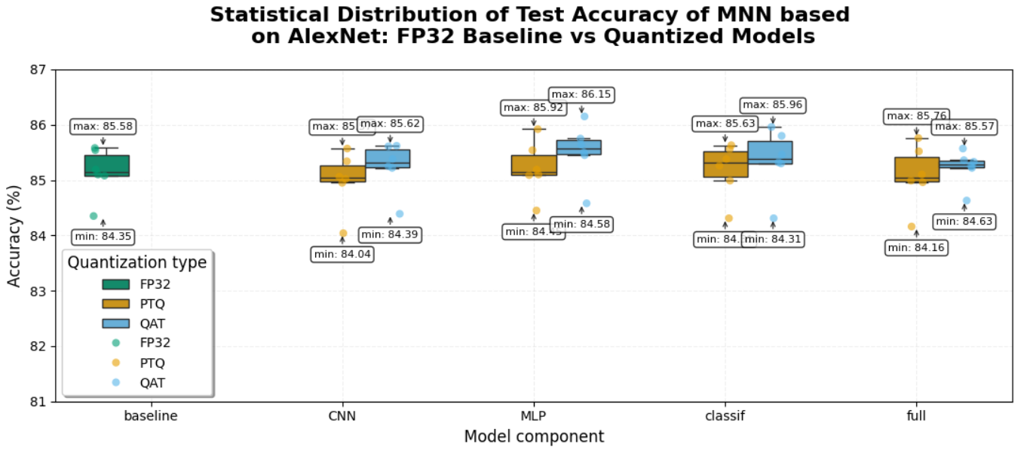

Figure 2. Statistical distribution of test accuracy for the MNN based on the AlexNet CNN for the Baseline FP32 model and quantized models using the PTQ and QAT methods

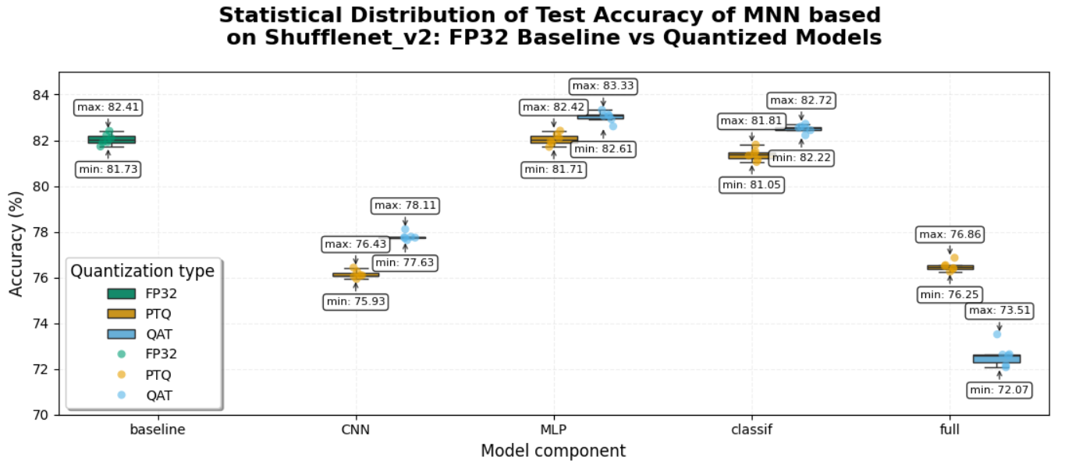

Figure 3. Statistical distribution of test accuracy for the MNN based on the Shufflenet_v2 CNN for the Baseline FP32 model and quantized models using the PTQ and QAT methods

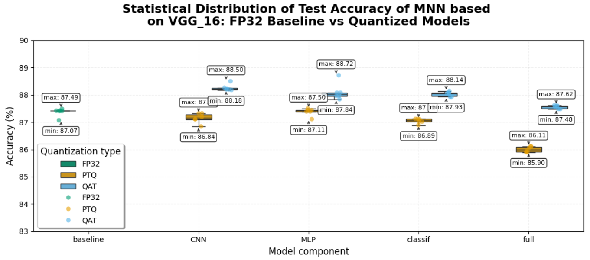

Figure 4. Statistical distribution of test accuracy for the MNN based on the VGG_16 CNN for the Baseline FP32 model and quantized models using the PTQ and QAT methods

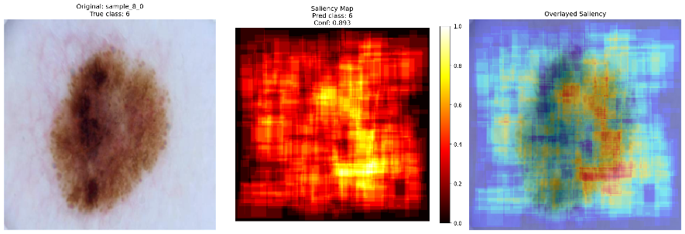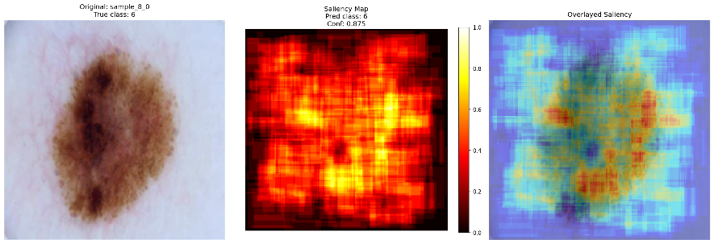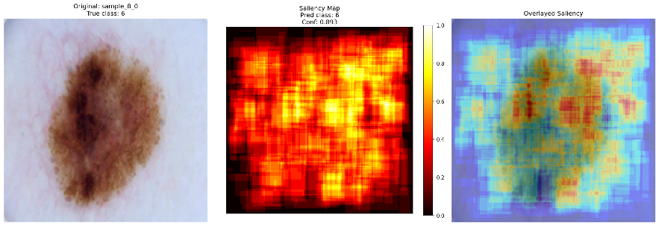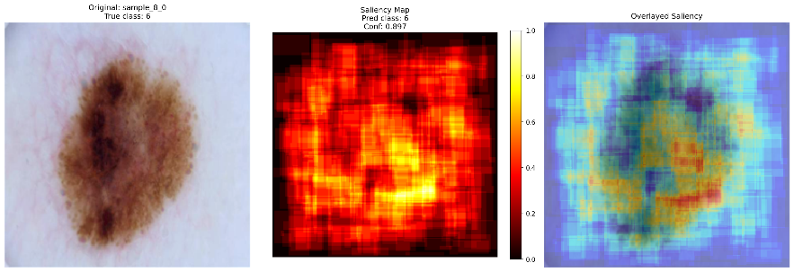

|  |  |  |  |  |
| --- | --- | --- | --- | --- |
| a) | b) | c) | d) | e) |

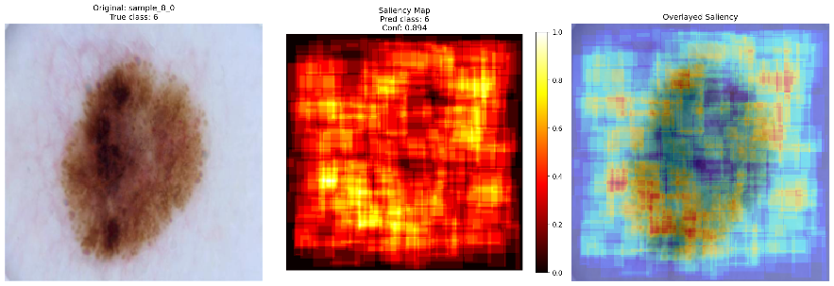 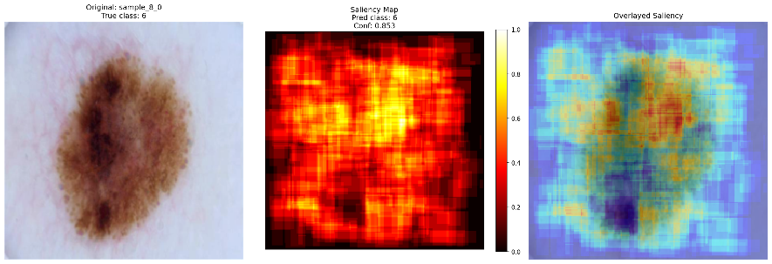 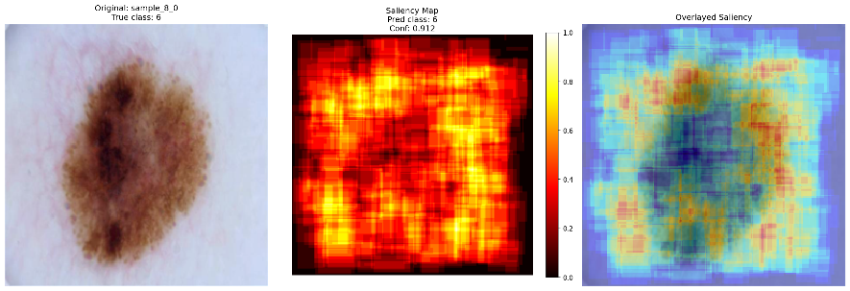 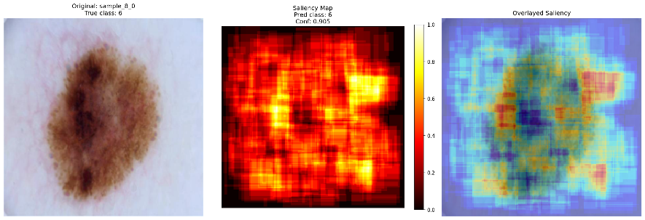 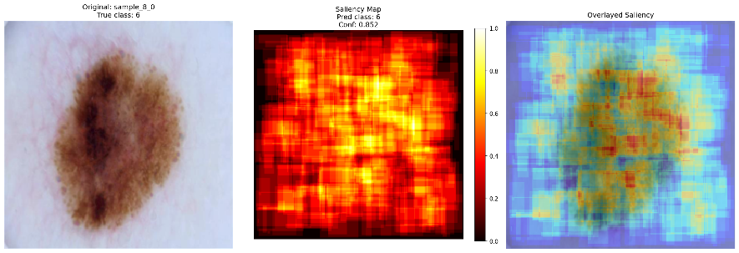

|  |  |  |  |  |
| --- | --- | --- | --- | --- |
| f) | g) | h) | i) | j) |

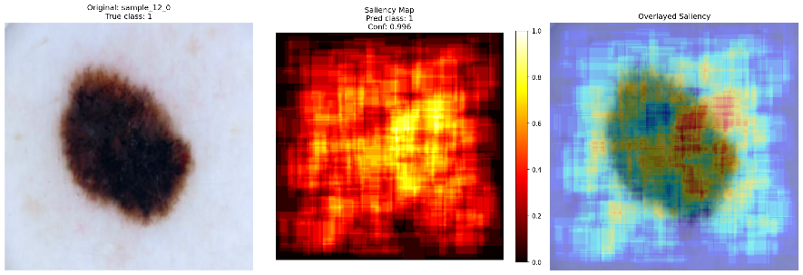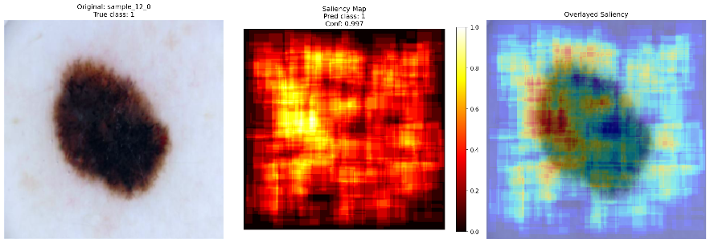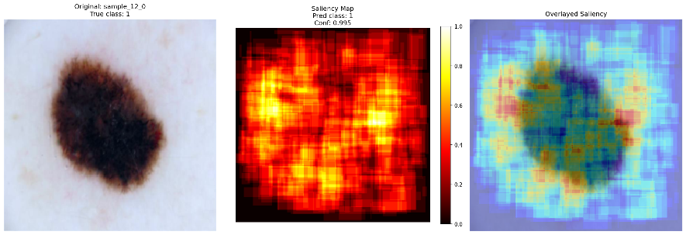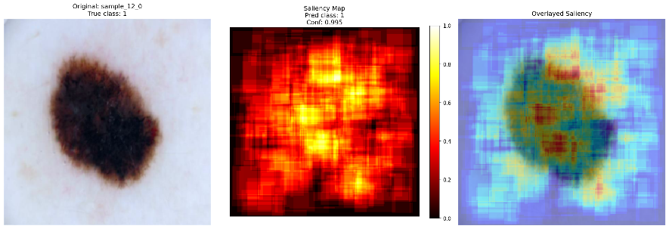

|  |  |  |  |  |
| --- | --- | --- | --- | --- |
| a) | b) | c) | d) | e) |

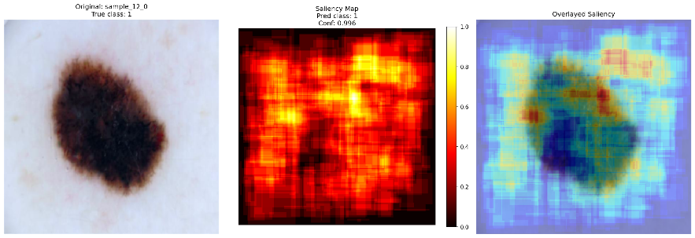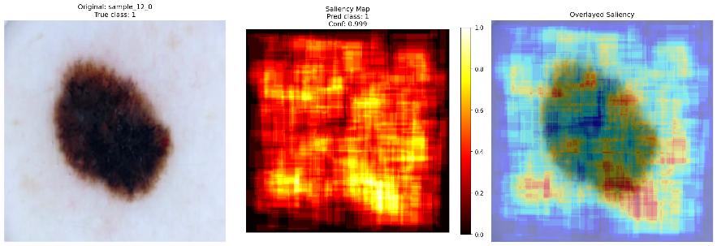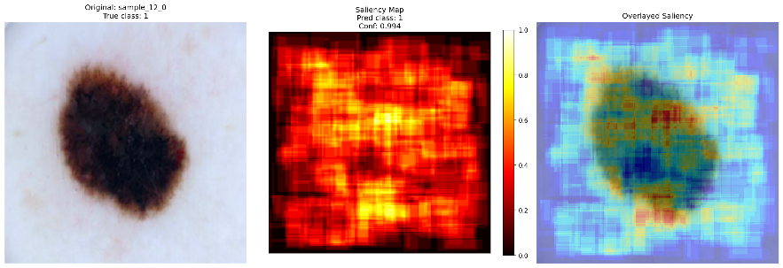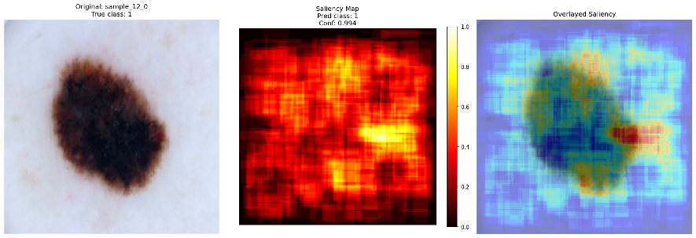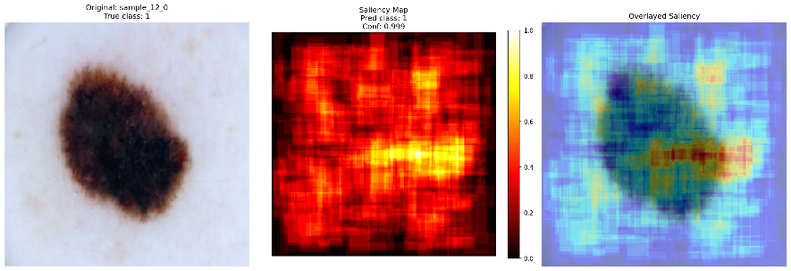

|  |  |  |  |  |
| --- | --- | --- | --- | --- |
| f) | g) | h) | i) | j) |

Figure 5. Original dermatological images (a) and attention maps obtained as a result of testing MNN based on CNN AlexNet: b) FP32 baseline; c) PTQ_CNN; d) PTQ_MLP; e) PTQ_classif; f) PTQ_full; g) QAT_CNN; h) QAT_MLP; i) QAT_classif; j) QAT_full

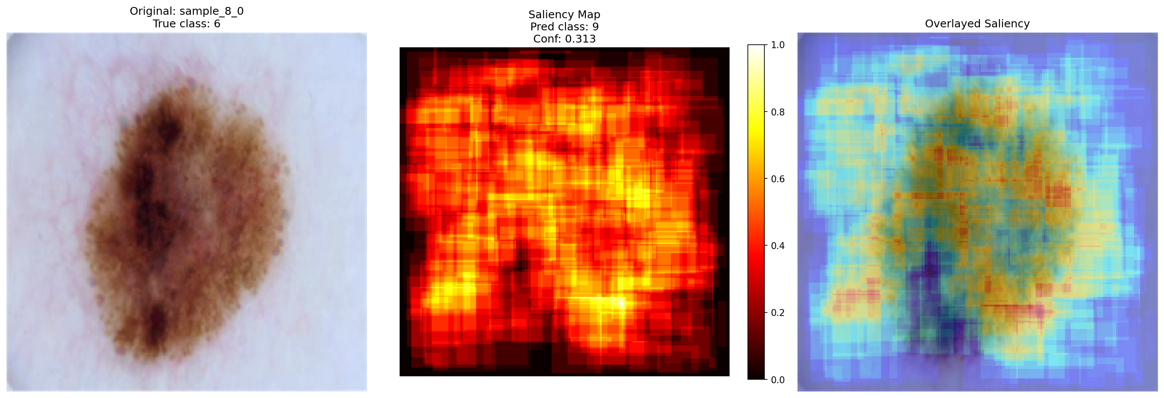 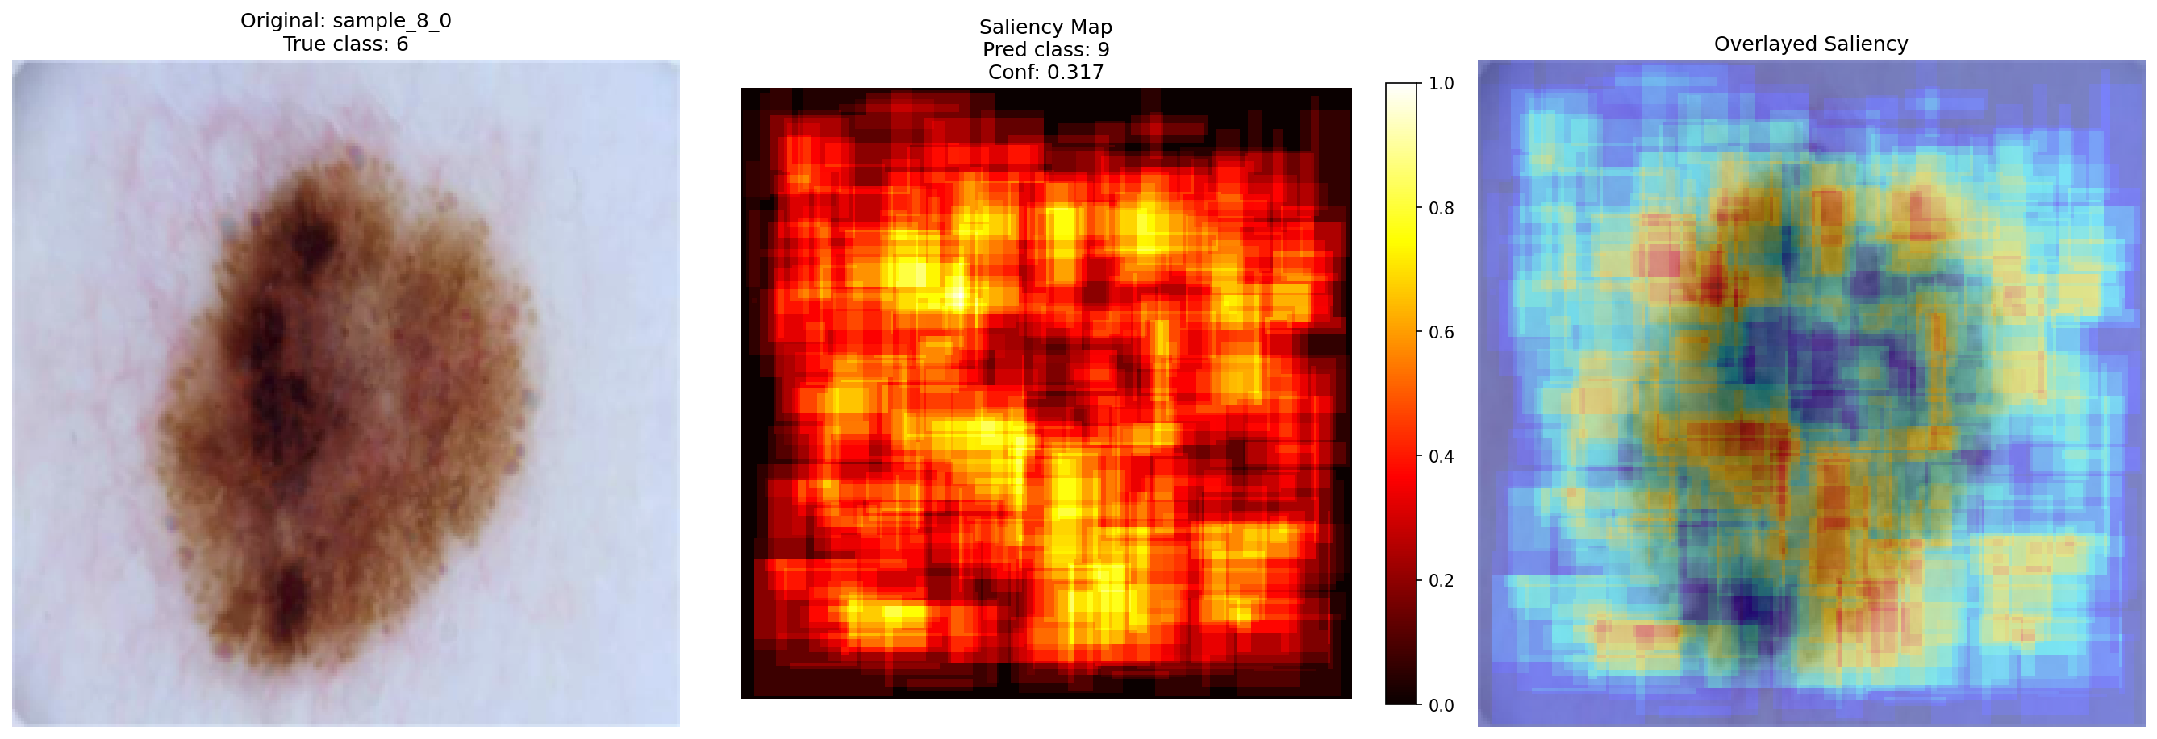 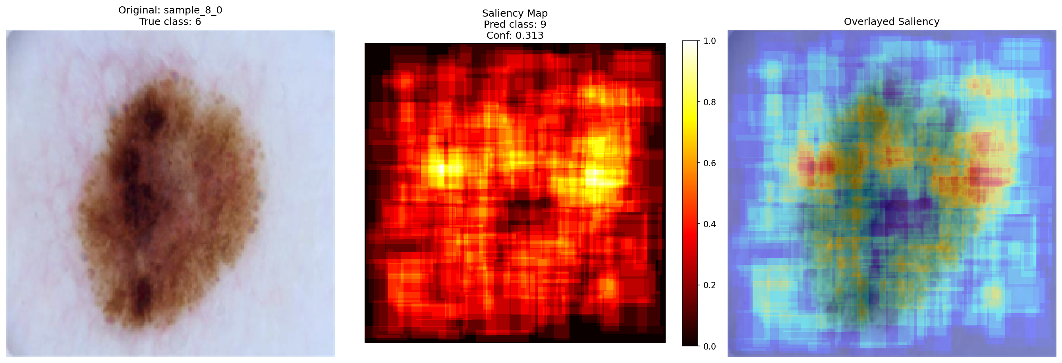 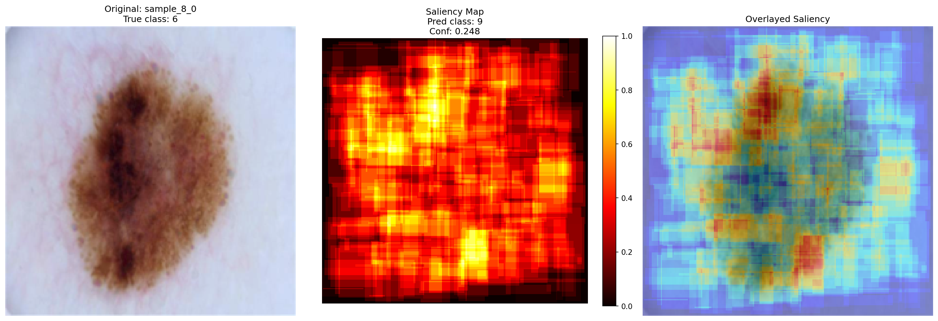

|  |  |  |  |  |
| --- | --- | --- | --- | --- |
| a) | b) | c) | d) | e) |

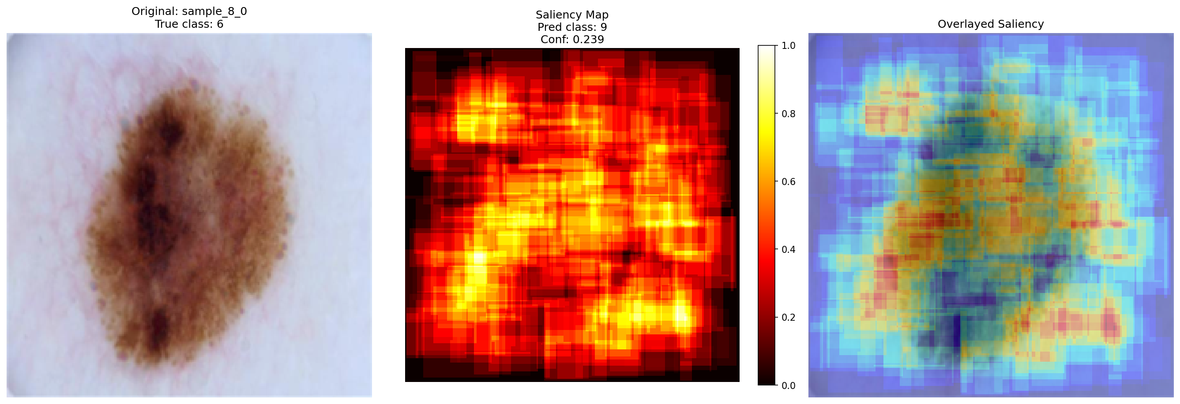 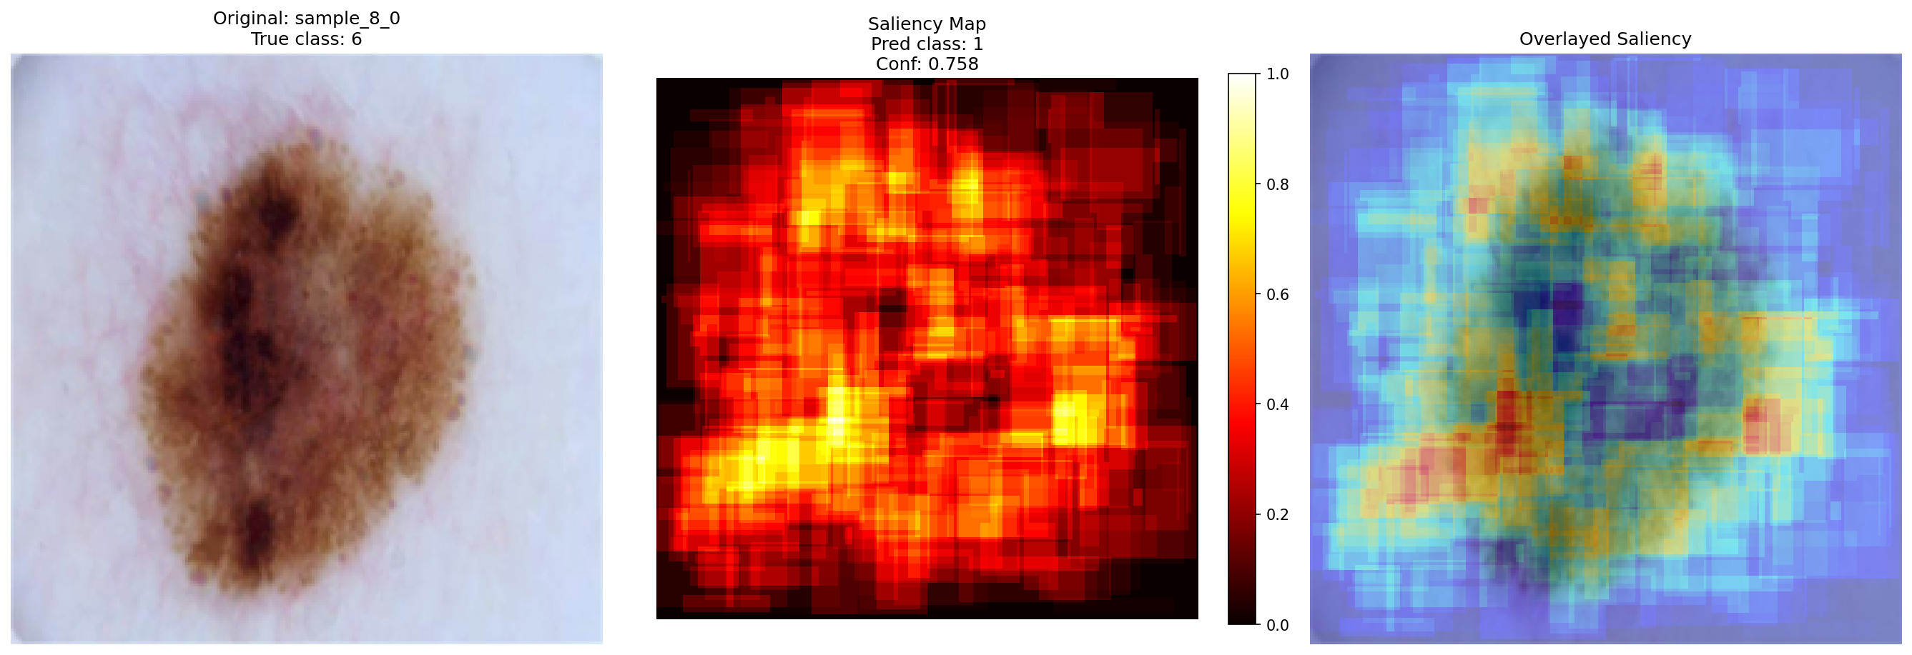 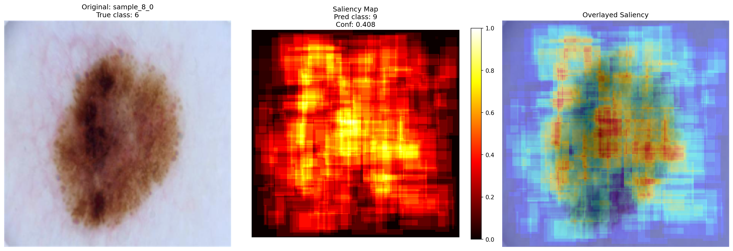 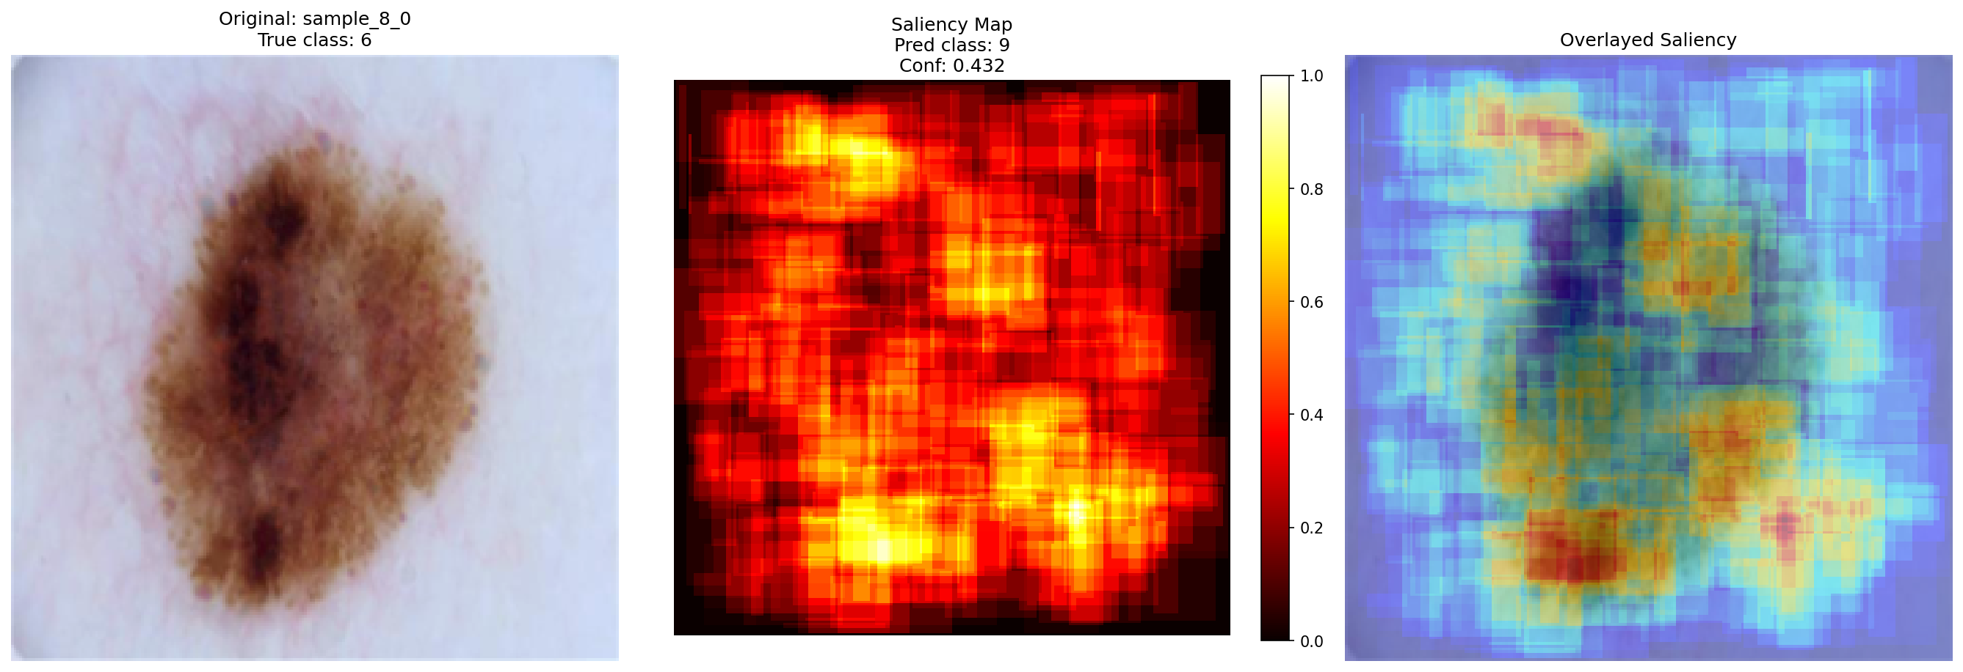 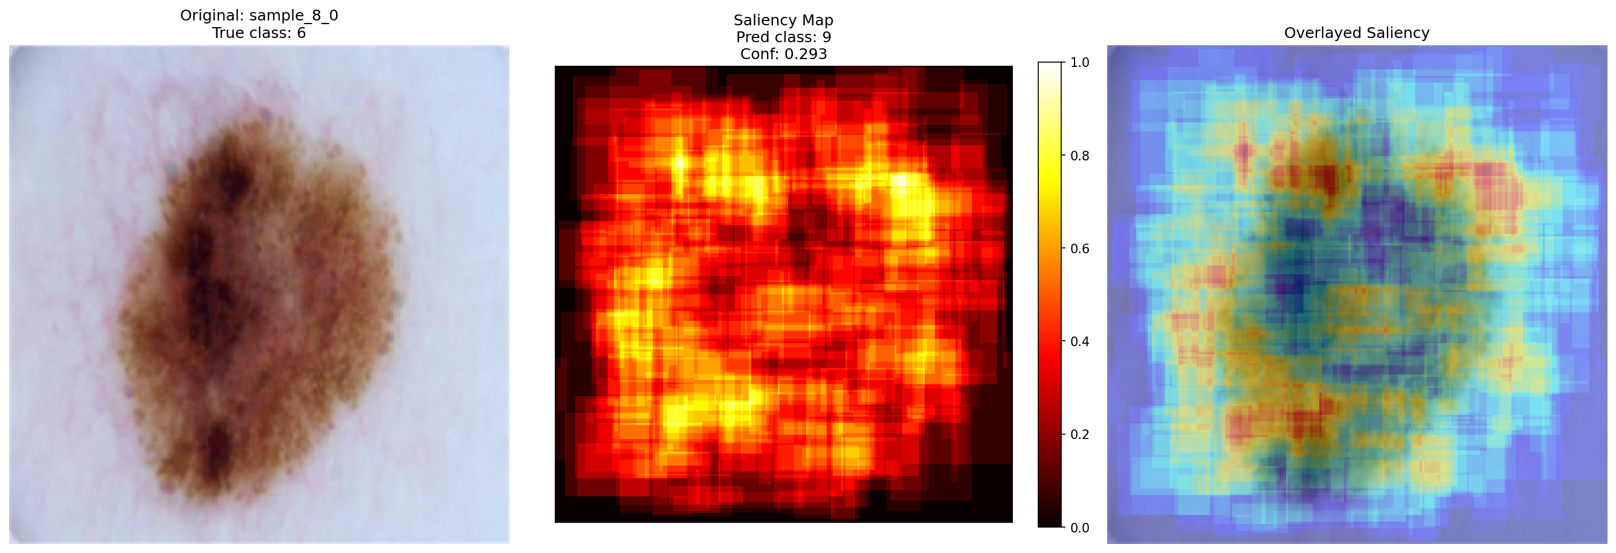

|  |  |  |  |  |
| --- | --- | --- | --- | --- |
| f) | g) | h) | i) | j) |

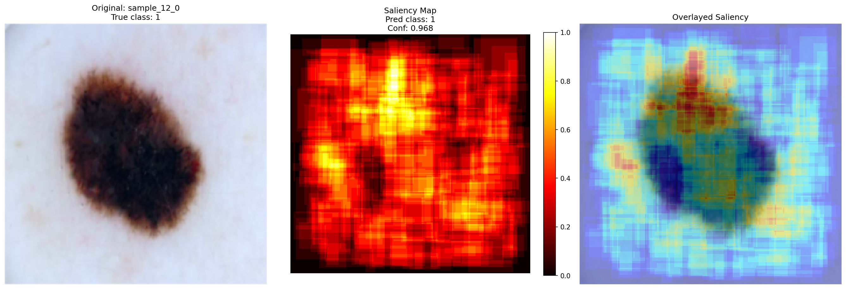 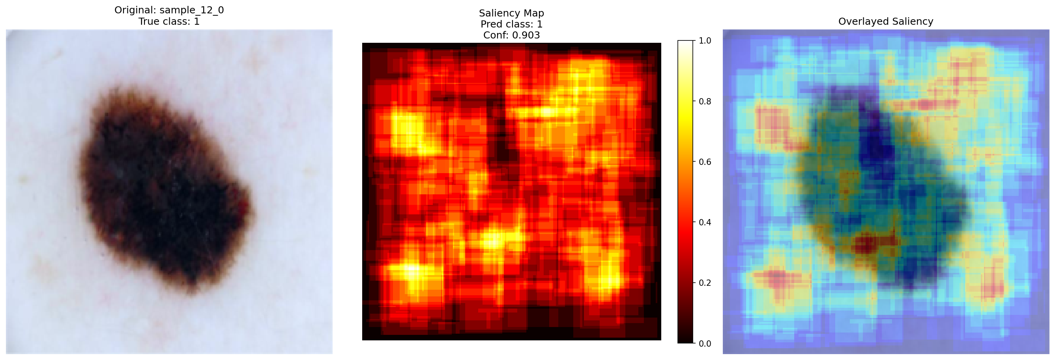 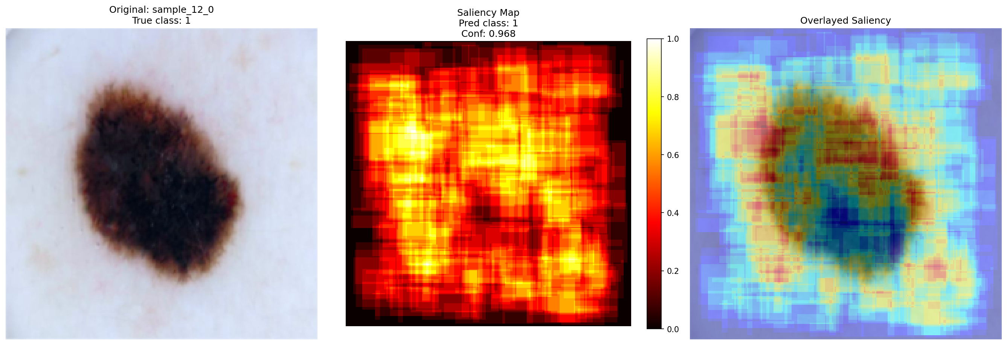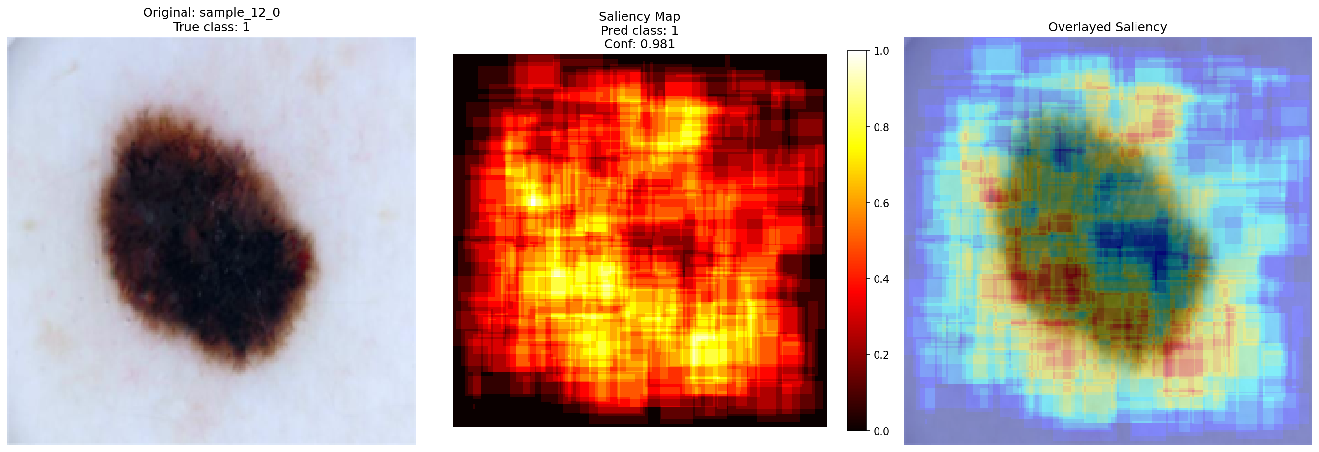

|  |  |  |  |  |
| --- | --- | --- | --- | --- |
| a) | b) | c) | d) | e) |

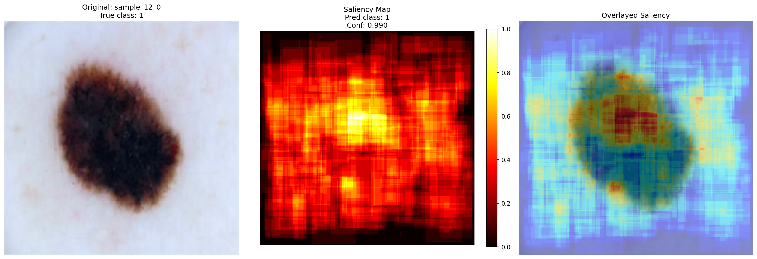 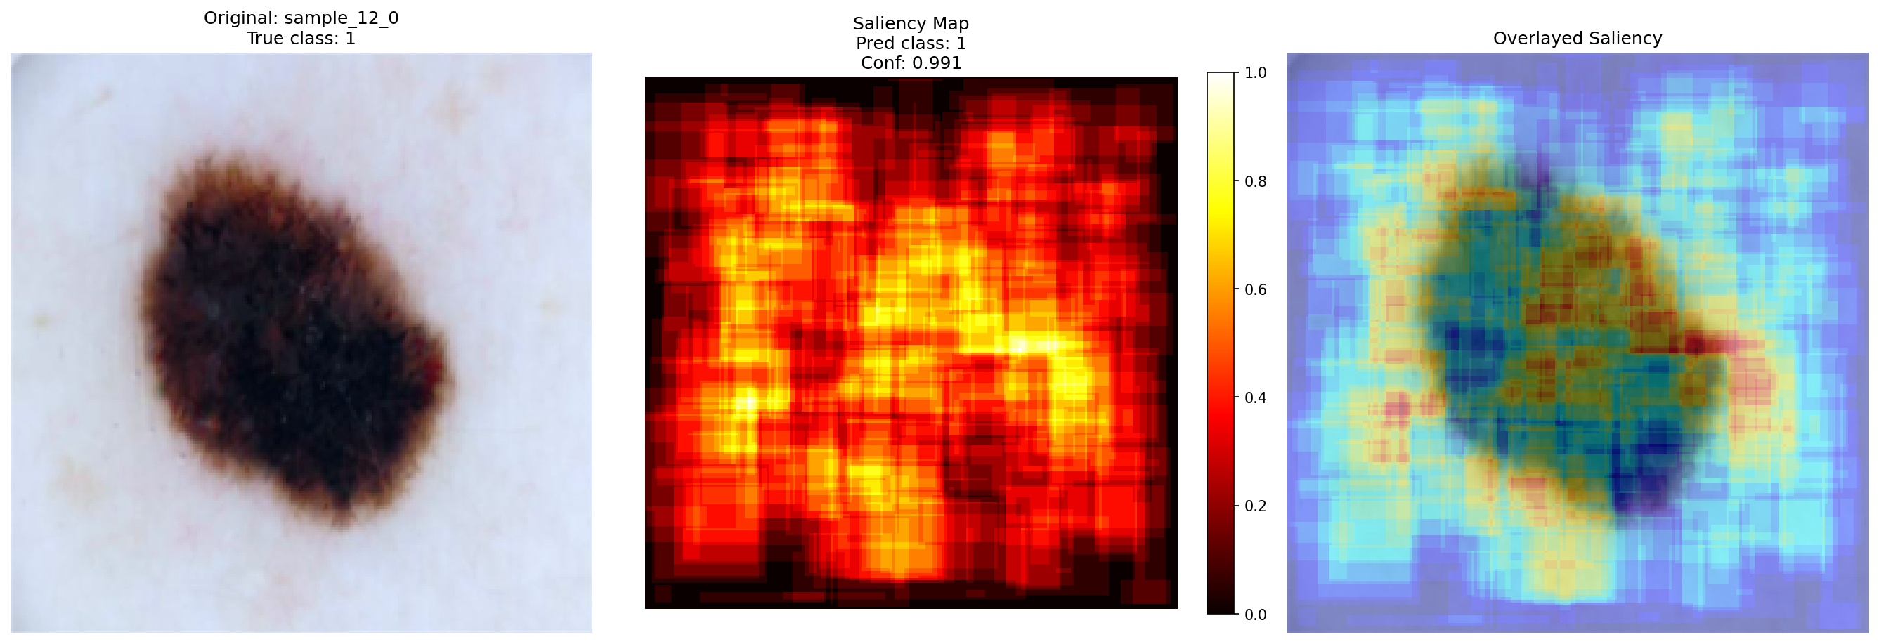 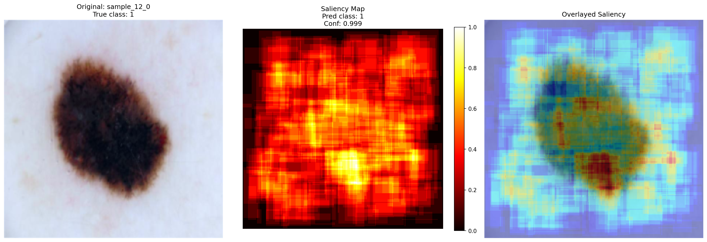 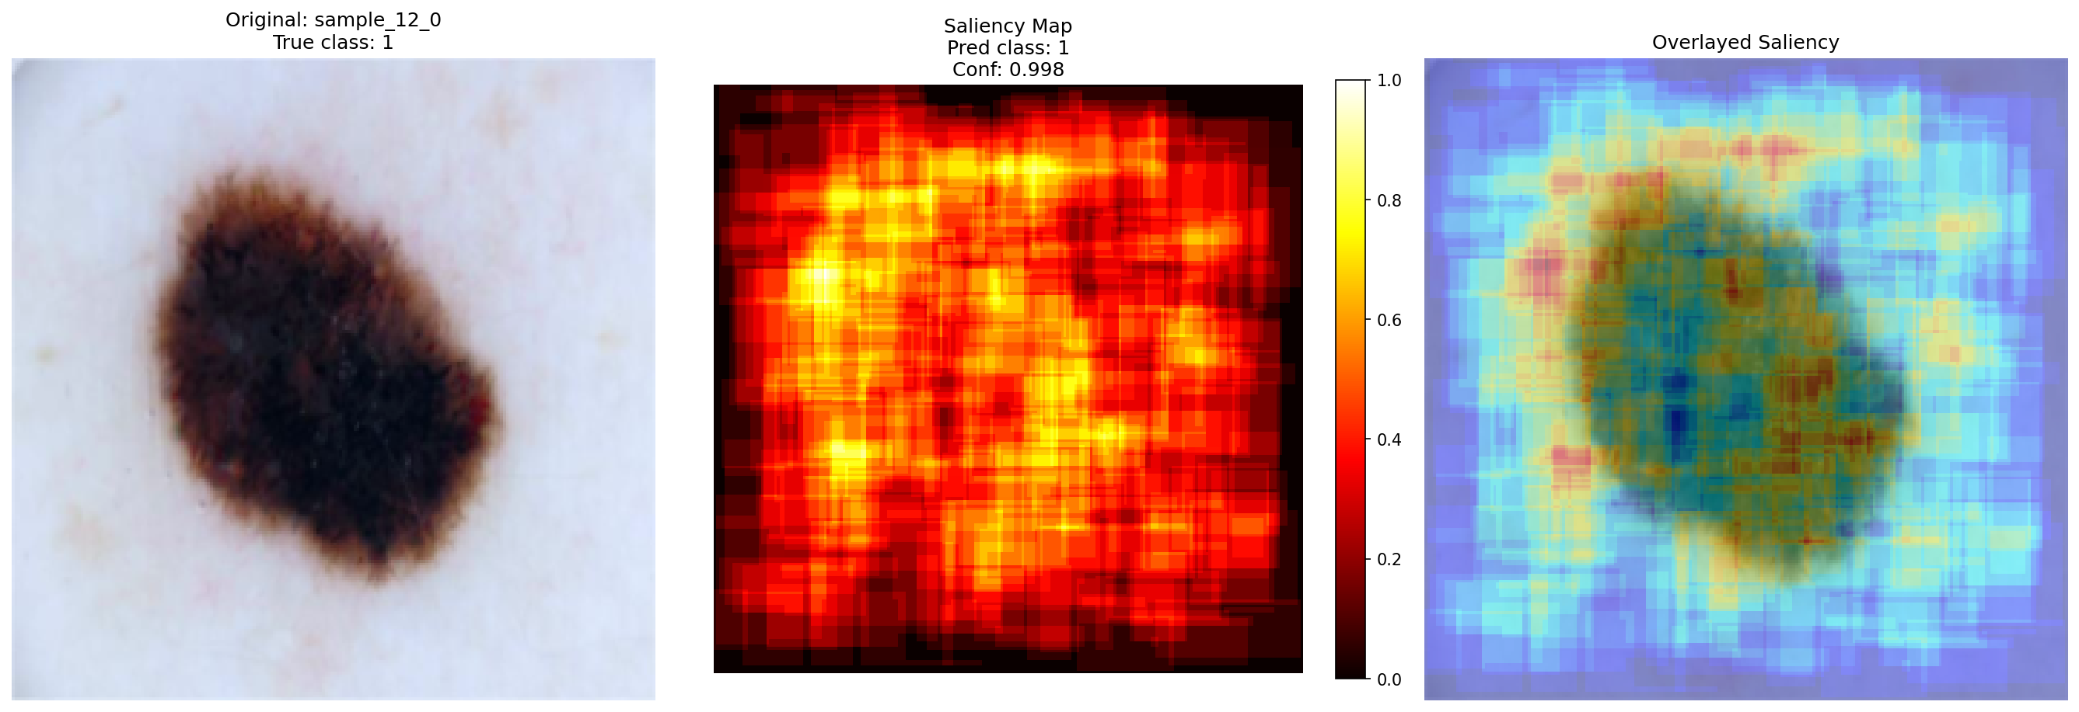 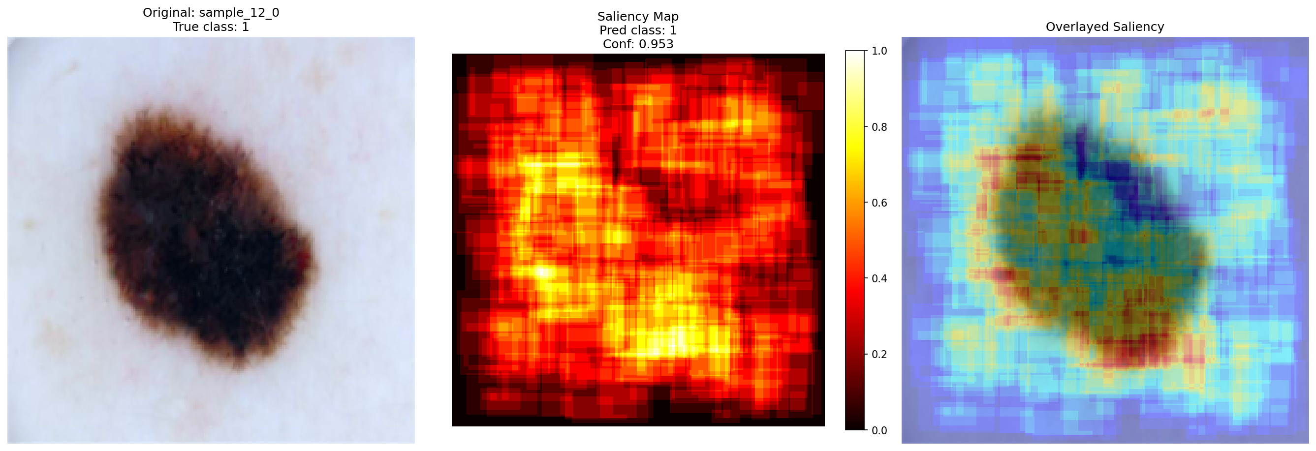

|  |  |  |  |  |
| --- | --- | --- | --- | --- |
| f) | g) | h) | i) | j) |

Figure 6. Original dermatological images (a) and attention maps obtained as a result of testing MNN based on CNN Shufflenet_v2: b) FP32 baseline; c) PTQ_CNN; d) PTQ_MLP; e) PTQ_classif; f)

PTQ_full; g) QAT_CNN; h) QAT_MLP; i) QAT_classif; j) QAT_full

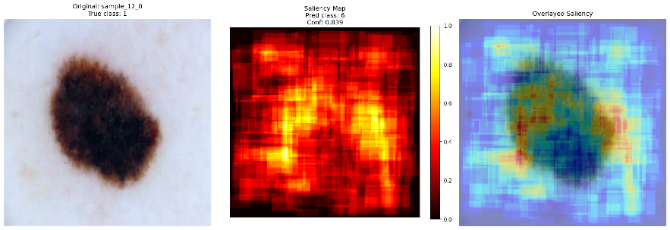 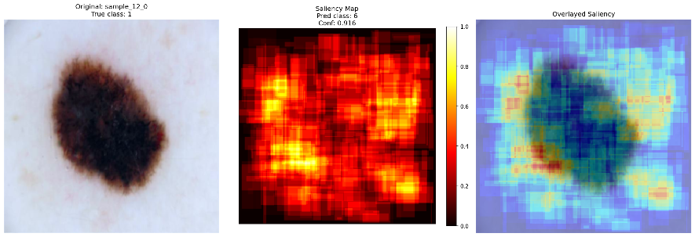 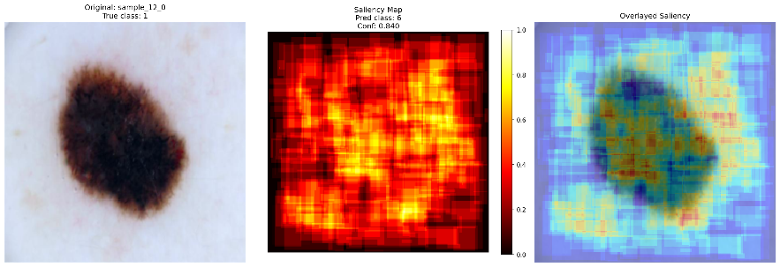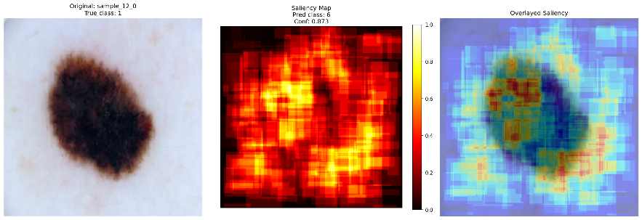

|  |  |  |  |  |
| --- | --- | --- | --- | --- |
| a) | b) | c) | d) | e) |

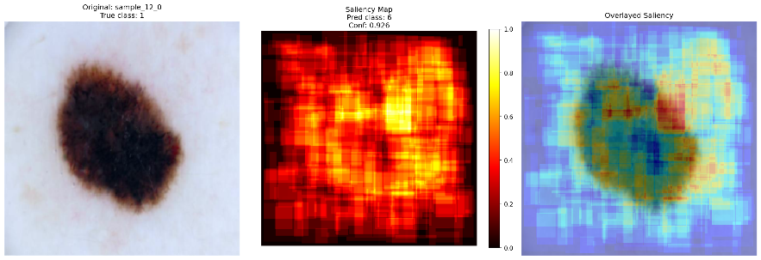 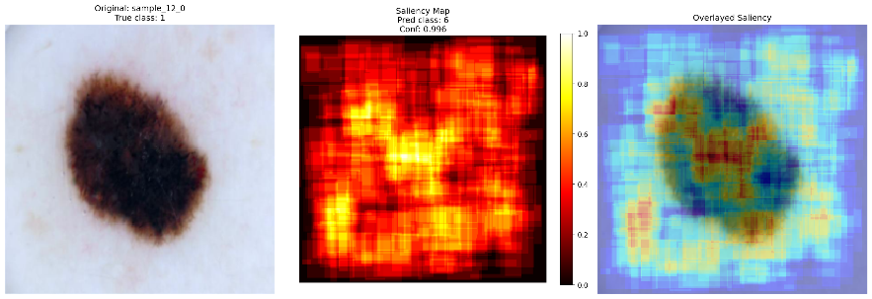 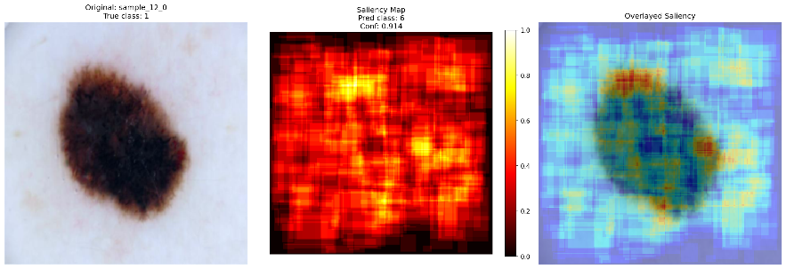 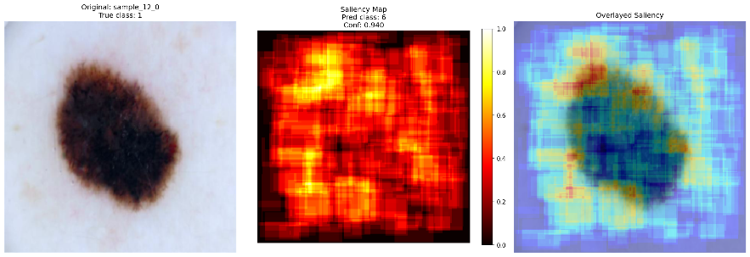 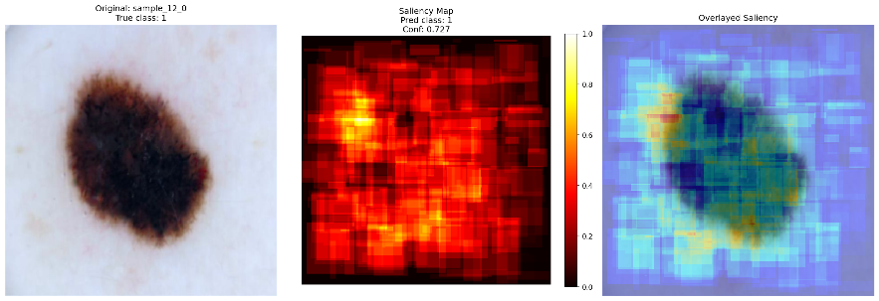

|  |  |  |  |  |
| --- | --- | --- | --- | --- |
| f) | g) | h) | i) | j) |

Figure 7. Original dermatological images (a) and attention maps obtained as a result of testing MNN based on CNN VGG_16: b) FP32 baseline; c) PTQ_CNN; d) PTQ_MLP; e) PTQ_classif; f) PTQ_full; g) QAT_CNN; h) QAT_MLP; i) QAT_classif; j) QAT_full

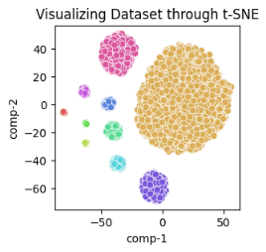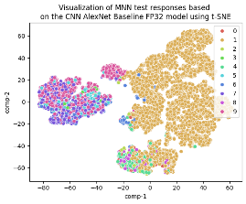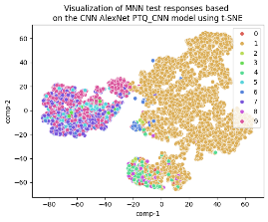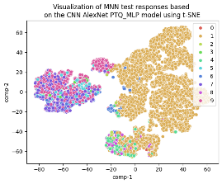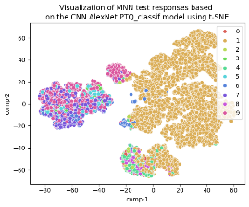

|  |  |  |  |  |
| --- | --- | --- | --- | --- |
| a) | b) | c) | d) | e) |

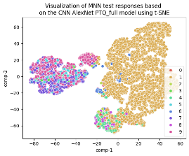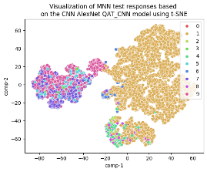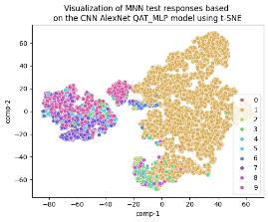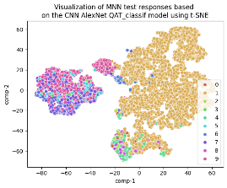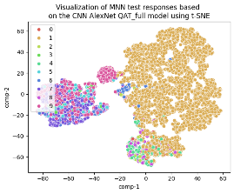

|  |  |  |  |  |
| --- | --- | --- | --- | --- |
| f) | g) | h) | i) | j) |

Figure 8. Visualization of the original distribution of test images (a) and the responses of MNN models based on AlexNet in 2D space using the t-SNE method: b) FP32 baseline; c) PTQ_CNN; d) PTQ_MLP; e) PTQ_classif; f) PTQ_full; g) QAT_CNN; h) QAT_MLP; i) QAT_classif; j) QAT_full

 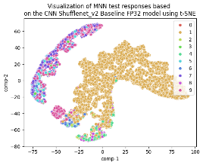 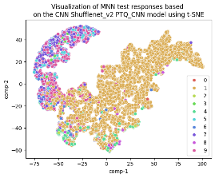 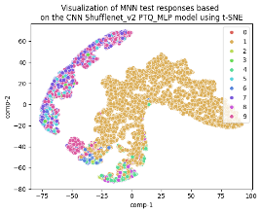 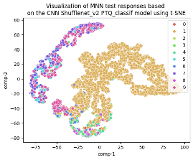

|  |  |  |  |  |
| --- | --- | --- | --- | --- |
| a) | b) | c) | d) | e) |

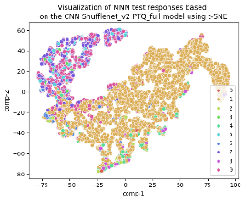 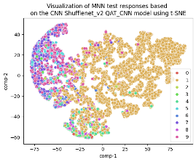 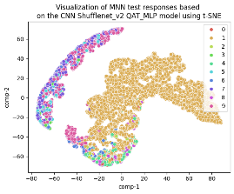 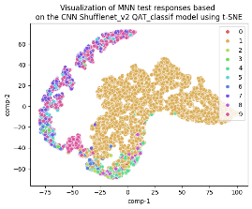 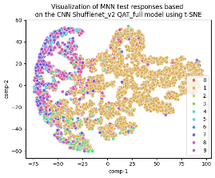

|  |  |  |  |  |
| --- | --- | --- | --- | --- |
| f) | g) | h) | i) | j) |

Figure 9. Visualization of the original distribution of test images (a) and the responses of MNN models based on Shufflenet_v2 in 2D space using the t-SNE method: b) FP32 baseline; c) PTQ_CNN; d) PTQ_MLP; e) PTQ_classif; f) PTQ_full; g) QAT_CNN; h) QAT_MLP; i) QAT_classif; j) QAT_full

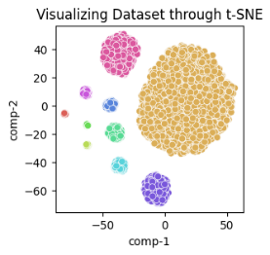 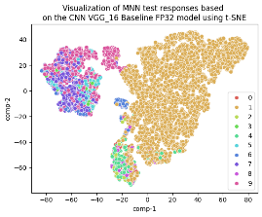 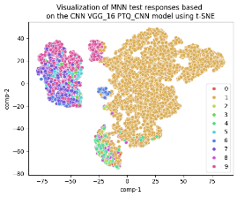 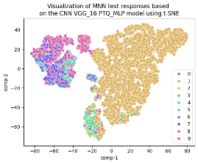 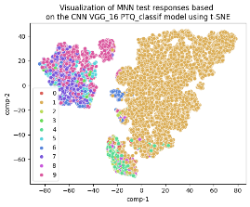

|  |  |  |  |  |
| --- | --- | --- | --- | --- |
| a) | b) | c) | d) | e) |

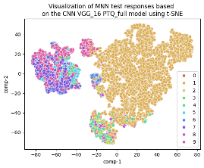 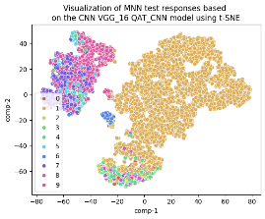 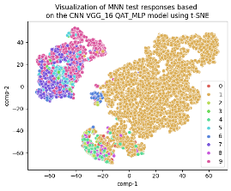 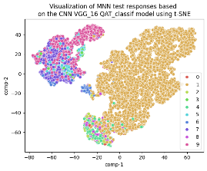 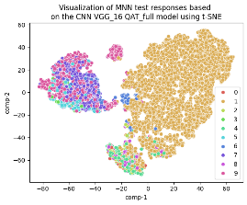

|  |  |  |  |  |
| --- | --- | --- | --- | --- |
| f) | g) | h) | i) | j) |

Figure 10. Visualization of the original distribution of test images (a) and the responses of MNN models based on VGG_16 in 2D space using the t-SNE method: b) FP32 baseline; c) PTQ_CNN; d) PTQ_MLP; e) PTQ_classif; f) PTQ_full; g) QAT_CNN; h) QAT_MLP; i) QAT_classif; j) QAT_full

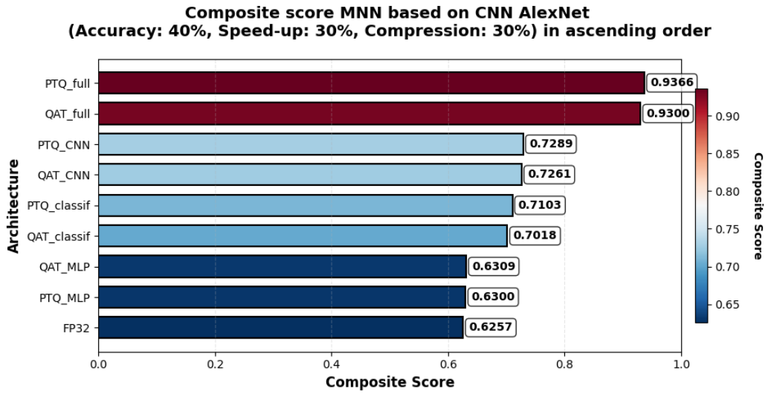

Figure 11. Composite evaluation plot of MNN based on CNN AlexNet (Accuracy: 40%, Speedup: 30%, Compression: 30%) in ascending order

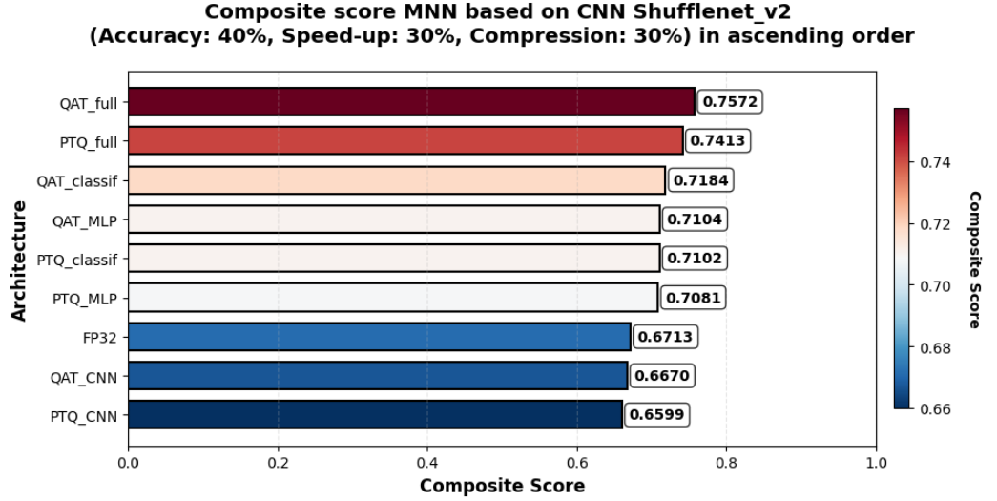

Figure 12. Composite evaluation plot of MNN based on CNN Shufflenet_v2 (Accuracy: 40%, Speedup: 30%, Compression: 30%) in ascending order

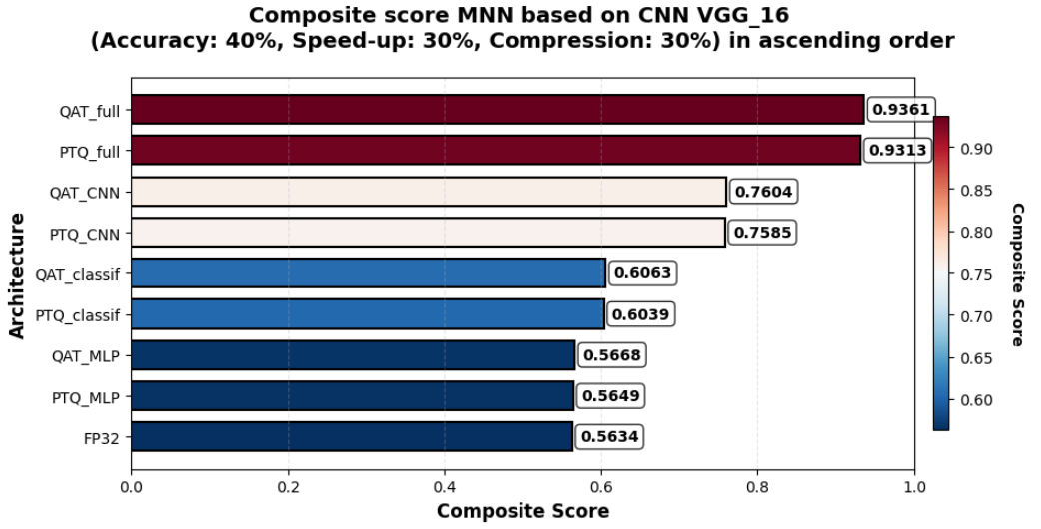

Figure 13. Composite evaluation plot of MNN based on CNN VGG_16 (Accuracy: 40%, Speedup: 30%, Compression: 30%) in ascending order

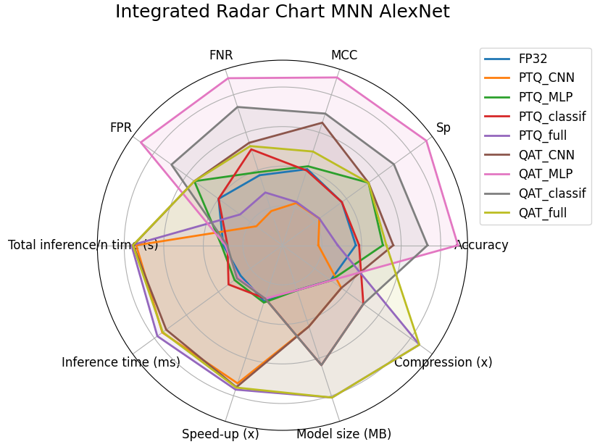 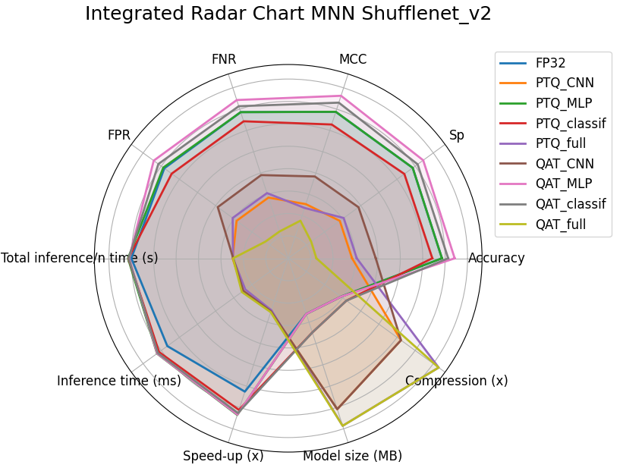

|  |  |
| --- | --- |
| a) | b) |

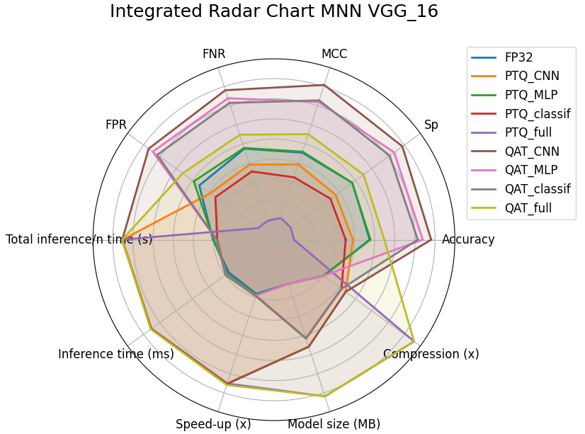

c)

Figure 14. Integrated radar map for the proposed MNN FP32 baseline models and quantized models using PTQ and QAT methods based on CNN architectures: a) AlexNet; b) Shufflenet_v2; c) VGG_16

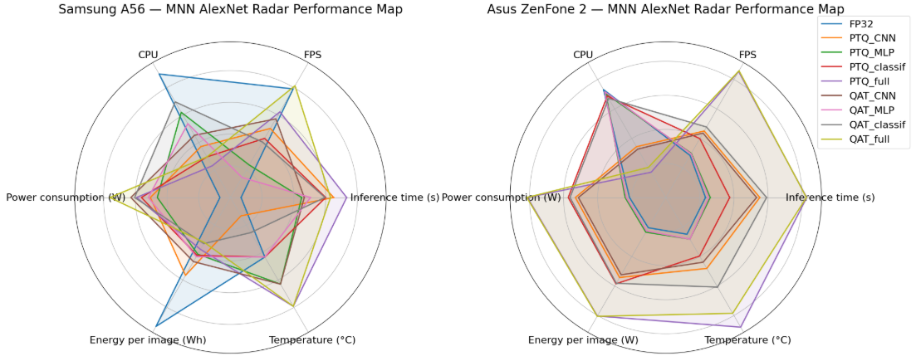

|  |  |
| --- | --- |
| a) | b) |

Figure 15. Integrated radar performance map for the proposed MNN FP32 baseline models and quantized models by PTQ and QAT methods based on AlexNet CNN architecture on mobile edge devices: a) Samsung Galaxy A56; b) ASUS Zenfone 2

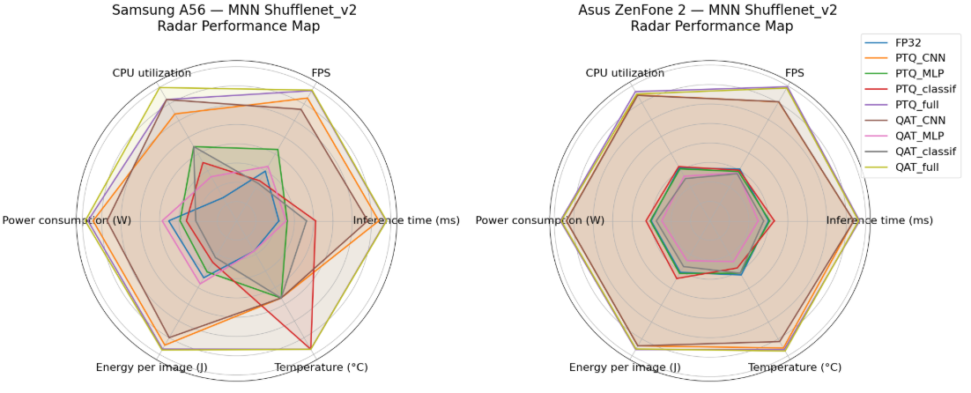

|  |  |
| --- | --- |
| a) | b) |

Figure 16. Integrated radar performance map for the proposed MNN FP32 baseline models and quantized models by PTQ and QAT methods based on Shufflenet_v2 CNN architecture on mobile edge devices: a) Samsung Galaxy A56; b) ASUS Zenfone 2

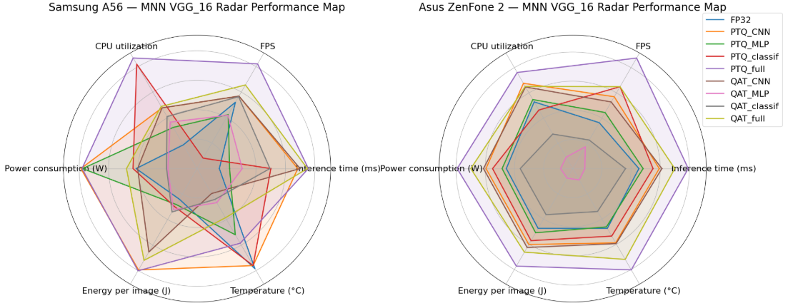

|  |  |
| --- | --- |
| a) | b) |

Figure 17. Integrated radar performance map for the proposed MNN FP32 baseline models and quantized models by PTQ and QAT methods based on VGG_16 CNN architecture on mobile edge devices: a) Samsung Galaxy A56; b) ASUS Zenfone 2

a) 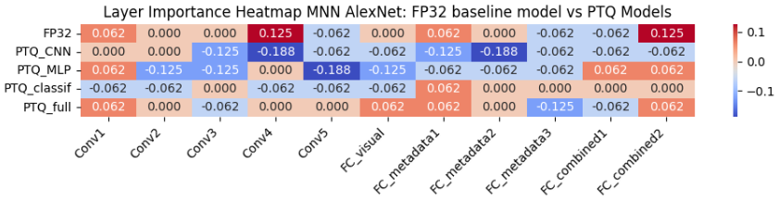

b) 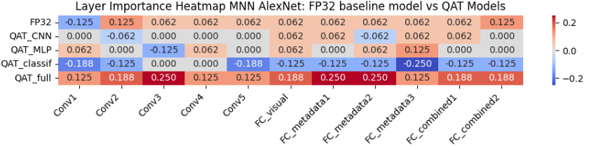

Figure 18. Heatmap of the importance of the main layers of MNN AlexNet: a) baseline FP32 model and quantized models by PTQ method; b) baseline FP32 model and quantized models by QAT method

a) 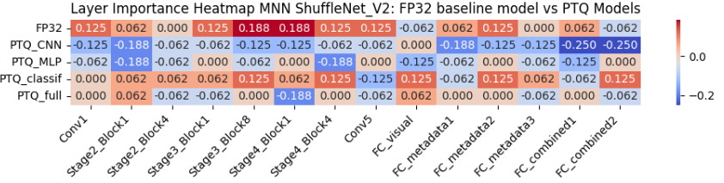

b) 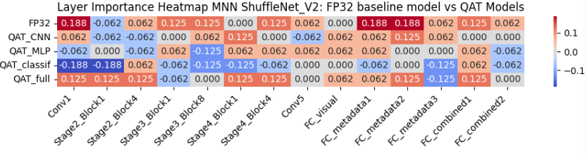

Figure 19. Heatmap of the importance of the main layers of MNN ShuffleNet_V2: a) baseline FP32 model and quantized models by PTQ method; b) baseline FP32 model and quantized models by QAT method

a) 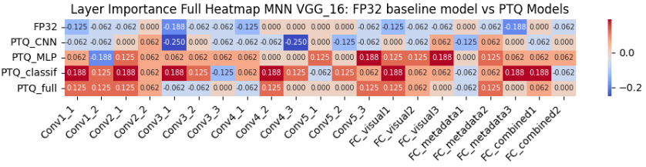

b) 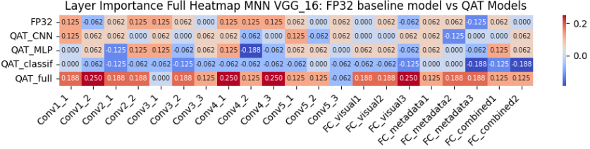

Figure 20. Heatmap of the importance of the main layers of MNN VGG_16: a) baseline FP32 model and quantized models by PTQ method; b) baseline FP32 model and quantized models by QAT method